E-Futures International UserGuide
Table Of Contents
Quick Start 2
Contract Setup 2
Account Summary 3
Confirmations 4
Notifications 5
Sound alerts 6
Overview 8
File 8
Logon 8
Logoff 8
Exit 8
Account 9
Average positions 9
Detailed position 10
Select Account 10
Account Filter 10
Orders 11
Order Tickets 11
Abbreviated Order Entry (AOE) 11
Turbo Order Entry (TOE) 11
Rapid Order Entry (ROE) 12
Depth of Market Order Entry (DOM) 12
Order default 13
Contract Setup 13
Confirmations 13
Notifications 14
Show Orders 15
Communications 15
Sound alert 15
Message History 16
Chat/Research Windows 17
Close/Open 17
Quotes 17
Add Remove Market and Group 18
Add Market 18
Add Market Group 18
Remove Market 19
Remove All Markets 19
Customize Appearance 19
Insert Blank Line 19
Move up/Move Down 19
Sort by Alpha 19
Customize Format 19
Custom Price Format 19
Font 20
Rename... 20
Quote alerts 21
Add,Remove Price Alert 21
View Price Alerts... 21
View 22
Lock/Unlock Windows 22
Layout 22
Save... 22
Delete... 23
Configure windows 23
Positions Window 23
Other Windows 23
Access Reports 24
Daily Fills 24
Daily Activity 24
Working Orders 24
Rejected Orders 24
Order Statistics 24
Order Ticket Statistics 24
P/L Summary 24
Chat History 24
News History 24
Order Details 24
Daily Positions 24
Trade Log 24
Open Orders 24
Setup 25
Shortcut Manager 25
Quick Start 25
Toolbox 26
Contract List 26
Contract Margins 26
Contract Specs 26
Glossary 26
Help 26
Contact Us 26
About 27
Open Live Account (DEMO ONLY) 27
Demo Only 27
File 28
Logon 28
Logoff 28
Exit 29
Account 31
Average positions 31
Detailed position 31
Select Account 31
Account Filter 31
Orders 33
Order Tickets 33
Abbreviated Order Entry (AOE) 33
Side 33
Buy 33
Sell 33
Market Selection 33
Quantity 33
Symbol 33
Order Specs 33
Type 33
Market (MKT) 33
Limit (LMT) 34
Stop (STP) 34
Stop Limit (STP LMT) 34
Market If Touched (MIT) 34
Market To Limit (MKT2LMT) 34
Market On Open (MOO) 34
Market On Close (MOC) 34
Market On Pit Open (MOOPit) 34
Market On Pit Close (MOCPit) 34
Trailing Stop Loss (TrSTP) 34
Trailing Stop Limit (TrSTP LMT) 34
Flag 35
Good Till Cancelled (GTC) 35
Fill or Kill (FOK) 35
Immediate or Cancel (IOC) 35
AON 35
Hot Keys 35
Template 35
Save/Delete. 35
Transmit/New Order 35
Exit MKT 35
Trade Contract 35
Turbo Order Entry (TOE) 35
Side 36
Qty 36
Symbol 36
Type 36
MKT 36
LMT 36
STP 36
Price 36
Price2 37
Status 37
Toolbar/Hot Key 37
Transmit/new order 37
Submit All 37
Delete/clear 37
Load/Save 37
Rapid Order Entry (ROE) 37
Auto Factor Settings 37
Buy Stop Limit 37
Factors 38
BUY STOP 38
Stop 38
Limit 38
Sell Limit 38
Factors 38
SELL LIMIT 38
Market Selection 38
Quantity 38
Symbol 38
BUY ASK/SELL ASK 38
BUY ASK 38
SELL ASK 38
Ask 38
Size 38
BUY MARKET/SELL MARKET 38
Last 38
BUY BID/SELL BID 39
BUY BID 39
SELL BID 39
Bid 39
Size 39
Auto Factor Settings 39
Buy Limit 39
Factors 39
BUY LIMIT 39
Sell Stop Limit 39
Factors 39
SELL STOP 39
Stop 39
Limit 39
Depth of Market Order Entry (DOM) 39
Depth of Market Order Entry (DOM) 39
Open 39
View 40
Quotes 41
DOM - Opening 42
Quotes box 42
View 42
Depth of Market Order Entry 42
Charts 42
Bid 43
Right Click: STP 43
Left Click: LMT 43
Offer 44
Right Click: STP 44
Left Click: LMT 44
Modify Price/Quantity of an Order 44
Price of an Order 44
Quantity of an Order 45
Thumbtack 45
Stay on Top 46
Display Options 46
Auto Center Price 46
Open Order Stats 47
Auto Sum Bid/Ask 47
Open P/L 47
Open Pos Price 47
Show Tooltip 47
Number Pad 47
Font & Colors 48
Red/Green Indicator 49
Number Pad 49
Touch Pad 49
OCO Orders 49
Order Cancel Order (OCO) 49
Order Flags 50
Good Till Cancelled (GTC) 51
Fill or Kill (FOK) 51
Immediate or Cancel (IOC) 51
Stop Limit/Trailing Stop 51
Stop Limit (STP LMT) 51
Trailing Stop 52
Bracket Options 52
Buy Bracket 53
Sell Bracket 53
Account Filter 53
Qty 54
P/L 54
Open P/L or Current P/L 54
Position 55
Exit at MKT 56
Reverse 56
Cancel orders 57
Cancel Bids 57
Cancel All 58
Cancel Offers 58
At Market 58
Buy MKT 58
Go to Last 58
Sell MKT 58
Order Default 58
Contract Setup 59
Confirmations 60
Notifications 61
Show Orders 62
Communications 63
Sound alerts 63
Message History 63
Chat 64
Research 64
Quotes 66
Add Market 66
Add Market Group 66
Remove Market 66
Remove All Markets 67
Insert Blank Line 67
Move up/Move Down 67
Sort by Alpha 68
Custom Price Format 68
Font 68
Rename... 69
Add,Remove Price Alert 69
View Price Alerts... 70
Depth or Market (DOM) 70
Column Setup 71
Export to CSV 72
View 73
Lock/Unlock Windows 73
Show Tabs 73
Layout 74
Layout 74
Save... 74
Delete... 75
Configuring Windows 75
Docked Windows 75
Close 75
Undock 75
Configure... 76
Show Tool Bar 76
Top Header 76
Left Header 76
Undocked Windows 76
Move 76
Size 76
Maximize 76
Close 77
Configure... 77
Show Tool Bars 77
Dockable 77
Independent 77
Stay on Top 77
Docking a Window 77
Configure 78
Toolbar 79
Menu 79
Settings 79
Positions 79
Average positions 79
Detailed position 79
Account Summary 80
Open Orders 81
Completed Orders 81
Order Tickets 82
Abbreviated Order Entry (AOE) 82
Side 82
Buy 82
Sell 82
Market Selection 82
Quantity 82
Symbol 82
Order Specs 83
Type 83
Market (MKT) 83
Limit (LMT) 83
Stop (STP) 83
Stop Limit (STP LMT) 83
Market If Touched (MIT) 83
Market To Limit (MKT2LMT) 83
Market On Open (MOO) 83
Market On Close (MOC) 83
Market On Pit Open (MOOPit) 83
Market On Pit Close (MOCPit) 83
Trailing Stop Loss (TrSTP) 84
Trailing Stop Limit (TrSTP LMT) 84
Flag 84
Good Till Cancelled (GTC) 84
Fill or Kill (FOK) 84
Immediate or Cancel (IOC) 84
AON 84
Hot Keys 84
Template 84
Save/Delete. 84
Transmit/New Order 84
Exit MKT 84
Trade Contract 84
Turbo Order Entry (TOE) 84
Side 85
Qty 85
Symbol 85
Type 85
MKT 85
LMT 85
STP 85
Price 85
Price2 86
Status 86
Toolbar/Hot Key 86
Transmit/new order 86
Submit All 86
Delete/clear 86
Load/Save 86
Rapid Order Entry (ROE) 86
Auto Factor Settings 86
Buy Stop Limit 86
Factors 87
BUY STOP 87
Stop 87
Limit 87
Sell Limit 87
Factors 87
SELL LIMIT 87
Market Selection 87
Quantity 87
Symbol 87
BUY ASK/SELL ASK 87
BUY ASK 87
SELL ASK 87
Ask 87
Size 87
BUY MARKET/SELL MARKET 87
Last 87
BUY BID/SELL BID 88
BUY BID 88
SELL BID 88
Bid 88
Size 88
Auto Factor Settings 88
Buy Limit 88
Factors 88
BUY LIMIT 88
Sell Stop Limit 88
Factors 88
SELL STOP 88
Stop 88
Limit 88
Depth of Market Order Entry (DOM) 88
Depth of Market Order Entry (DOM) 88
Open 88
View 89
Quotes 90
DOM - Opening 91
Quotes box 91
View 91
Depth of Market Order Entry 91
Charts 91
Bid 92
Right Click: STP 92
Left Click: LMT 92
Offer 93
Right Click: STP 93
Left Click: LMT 93
Modify Price/Quantity of an Order 93
Price of an Order 93
Quantity of an Order 94
Thumbtack 94
Stay on Top 95
Display Options 95
Auto Center Price 95
Open Order Stats 96
Auto Sum Bid/Ask 96
Open P/L 96
Open Pos Price 96
Show Tooltip 96
Number Pad 96
Font & Colors 97
Red/Green Indicator 98
Number Pad 98
Touch Pad 98
OCO Orders 98
Order Cancel Order (OCO) 98
Order Flags 99
Good Till Cancelled (GTC) 100
Fill or Kill (FOK) 100
Immediate or Cancel (IOC) 100
Stop Limit/Trailing Stop 100
Stop Limit (STP LMT) 100
Trailing Stop 101
Bracket Options 101
Buy Bracket 102
Sell Bracket 102
Account Filter 102
Qty 103
P/L 103
Open P/L or Current P/L 103
Position 104
Exit at MKT 105
Reverse 105
Cancel orders 106
Cancel Bids 106
Cancel All 107
Cancel Offers 107
At Market 107
Buy MKT 107
Go to Last 107
Sell MKT 107
View Quotes 107
Symbol 108
Last 108
LastVol 108
Bid 108
BidSize 108
Ask 108
AskSize 108
High 108
Low 108
Chg 108
Chg% 108
TotalVol 109
Open 109
Settle 109
Updated 109
Base Contract 109
Expires 109
Description 109
Currency 109
Exchange 109
Group 109
Type 109
Start Time 109
Stop Time 109
Tick Size 109
Per Point 109
Charts 110
Charts - Open 110
Add Indicator 110
Add Indicator 110
Volatility 111
Average True Range (ATR) 112
Standard Deviation (StdDev) 112
Volatility (Volatility) 112
Volatility Chaikins (CHV) 112
Volatility Ratio (VR) 112
Channels 112
Bollinger Band 113
Commodity Channel Index 113
Envelope 113
Keltner Channel 113
Data 113
Volume 114
Moving Averages 114
Exponential M.A. (EMA) 114
Least Square M.A. (LSMA) 114
Rolling M.A. (RMA) 114
Simple M.A. (SMA) 115
Triangular M.A. (TMA) 115
Triple M.A. 115
Variable M.A. 115
Weighted M.A. 115
Oscillator 115
Average Directional Index 115
Detrended Price Oscillator 115
Momentum 116
Performance 116
Price Oscillator 116
Relative Strength Index 116
Stochastic (%K, %D) 116
William’s %R (%R) 116
Prices 116
Median Price (Median) 117
Typical Price (Typical) 117
Weighted Close (Weighted) 117
Trend Followers 117
MACD (MACD, Histogram, Signal) 117
Mass Index (MI) 117
Tangent of Linear Regression (Tangent) 117
TRIX (TRIX) 117
Volumes 117
Accumulation/Distribution (A/D) 118
Ease of Movement (EoM) 118
Money Flow Index (MFI) 118
Negative Volume Index (NVI) 118
On Balance Volume (OBV) 118
Positive Volume Index (PVI) 118
Price Volume Trend (PVT) 119
Volume Oscillator (VO) 119
Period 119
Profile 119
Save Profile 120
Save as Default 120
Delete Profile 120
Select Profile 120
ADX (Average Directional Index) 120
Bollinger Band 120
Volumes 120
Momentum 120
Default 120
Area 121
Properties: Chart Area X 121
Remove: Chart Area X 121
Freeze Limits 121
Auto Limits 121
Series 121
Move to New Area 122
Save As Default 122
Indicators... 122
Drawing Tools 122
Pointer 123
Trend 123
Line 123
Callout 123
Text 123
Horizontal Line 124
Vertical Line 124
Arrow 124
Send to Back 124
Bring to Front 124
Drawing Properties 124
Remove Drawing Object 125
Allow Selecting 126
Select All 126
Export 126
Print 126
Save Image 126
Save XML 126
Copy 126
Auto scroll 126
Offset 127
Zoom In (CTRL+I) 127
Zoom Out (CTRL+O) 127
Data Box 127
Crosshair Mode 127
Hidden 127
Free 127
Mouse 127
StickyClick 127
Sticky 127
Load More Data 127
Volume 128
Chart Properties 129
Properties 129
Current Profile 129
Appearance 129
Background Color 130
Background Gradient 130
Bid/Ask 130
Ask Color 131
Bid Color 131
Show Bid/Ask 132
Data Box 132
Crosshair on Mouse 132
Hidden 133
Free 133
Mouse 133
StickyClick 133
Sticky 133
Font 133
Show OHLC 134
Source 134
Last 135
Mouse 135
Crosshair 135
Visibility 135
Visible 135
Hidden 135
AutoHide 135
Grid and Others 135
Cursor 136
Color 136
Style 136
Width 136
Horizontal 136
Show Grid Lines 137
Grid Lines 137
Color 138
Style 138
Width 138
Label Color 138
Label Font 138
Show Tick Marks 138
Tick Marks 138
Color 139
Style 139
Width 139
Selection Color 139
Vertical 139
Show Grid Lines 140
Grid Lines 140
Color 140
Style 140
Width 140
Label Color 140
Label Font 140
Show Tick Marks 140
Tick Marks 140
Color 140
Style 140
Width 140
Scrolling 140
Auto Scroll 141
Show Right Margin 141
Chart Area 1 141
Misc 141
Custom Levels 141
Lower Limit 141
Upper Limit 142
Contract (ei: ESZ6) 142
Appearance 142
Chart Style 142
Color 142
Styles 142
Visible 142
Candlestick 142
Bearish 143
Bullish 143
Misc 143
Session 143
24 hours 144
Contract Setup 144
Custom 144
Additional Indicators 144
Appearance 144
Chart Style 145
Color 145
Styles 145
Visible 145
Data 145
Input 146
Period of indicator 146
Orders 146
Appearance 146
Font 146
Color of Text 147
Cancel Command 147
Color of fills 147
Modify Command 148
Normal Order 148
Filter 148
Cancel Commands 148
Cancelled Orders 148
Completed Orders 148
Fills 148
Modify Commands 148
Rejected Orders 148
Visible 148
Working Orders 149
Format 149
Aggregated Fills 149
Full Format 149
Order ID 149
Price 149
Quantity 149
Ticket # 149
Type 149
Data 149
Data 149
Date/Time 150
Last updated 150
High, Low, Open, Close 150
Indicators 150
Channels 150
Channels 150
Bollinger Band 151
Commodity Channel Index 152
Envelope 152
Keltner Channel. 153
Moving Averages 154
Exponential M.A. (EMA) 154
Least Square M.A. (LSMA) 155
Rolling M.A. (RMA) 156
Simple M.A. (SMA) 157
Triangular M.A. (TMA) 158
Triple M.A. 159
Variable M.A. 160
Weighted M.A. 161
Oscillator 162
Average Directional Index 162
Detrended Price Oscillator 163
Momentum 164
Performance 165
Price Oscillator 166
Rate of Change 167
Relative Strength Index 168
Stochastic (%K, %D) 169
William’s %R (%R) 170
Prices 171
Median Price (Median) 171
Typical Price (Typical) 171
Weighted Close (Weighted) 172
Trend Followers 172
MACD (MACD, Histogram, Signal) 172
Mass Index (MI) 172
Tangent of Linear Regression (Tangent) 172
TRIX (TRIX) 172
Volatility 172
Average True Range (ATR) 173
Standard Deviation (StdDev) 173
Volatility (Volatility) 173
Volatility Chaikins (CHV) 173
Volatility Ratio (VR) 173
Volumes 173
Accumulation/Distribution (A/D) 174
Ease of Movement (EoM) 174
Money Flow Index (MFI) 174
Negative Volume Index (NVI) 174
On Balance Volume (OBV) 174
Positive Volume Index (PVI) 174
Price Volume Trend (PVT) 174
Volume Oscillator (VO) 175
Communications 175
Research 175
Chat 175
Reports 177
Access Reports 177
Daily Fills 177
Daily Activity 177
Working Orders 177
Rejected Orders 177
Order Statistics 177
Order Ticket Statistics 177
P/L Summary 177
Chat History 177
News History 177
Order Details 177
Daily Positions 177
Trade Log 177
Open Orders 177
Setup 179
Shortcut Manager 179
Quick Start 179
Toolbox 181
Contract List 181
Contract Margins 181
Contract Specs 181
Glossary 181
Help 182
Contact Us 182
About 182
Open Live Account 183
Open Live Account (DEMO ONLY) 183
Demo Only 183
Advanced Features 184
Advanced Orders 184
Order Flags 184
Good Till Cancelled (GTC) 184
Fill or Kill (FOK) 184
Immediate or Cancel (IOC) 184
OCO Orders 184
Stop Limit/Trailing Stop 185
Stop Limit (STP LMT) 186
Trailing Stop (Tr STP) 186
How to execute 186
Bracket Options 186
Buy Bracket 187
Sell Limit 187
Sell Stop 187
Sell Bracket 187
Buy Stop 187
Buy Limit 187
Glossary 188
Index 191

Guide Downloads  - Adobe PDF | Webinars  - Archive

© 2006 Open E Cry, LLC | All Rights Reserved.
There is risk of loss in futures trading.

Quick Start

Contract Setup
- Every contract that appears in the "Selected" box will appear in your drop down lists for the order tickets and quotes window setup.
- Click on the desired group (i.e.) “Currencies” under the "Available" window and open it up so that you can see all of the contracts included in that window. Click to add a checkmark next to the contracts you want to see in your drop down lists for the order tickets and quotes window setup. You will see the contracts move to the “Selected” box as you select them.
- Once you have added the desired contracts to the contract setup “Selected” box you will next want to select the months that you want to trade. If you change the month’s column to the “Nearest 2” selection you will most likely have the contract months you trade. If the month you trade is not part of the Nearest 2 selection then select “All Months”. Make sure that you click “Set Months” before exiting the “Contract Setup” window or else your settings will not be saved.
- You can also set a default quantity for one or many contracts at once by pressing CTRL and selecting the contracts then, set the Def. Qty. and hit "Set Qty". Note: This settings will show once you log off and log back in.
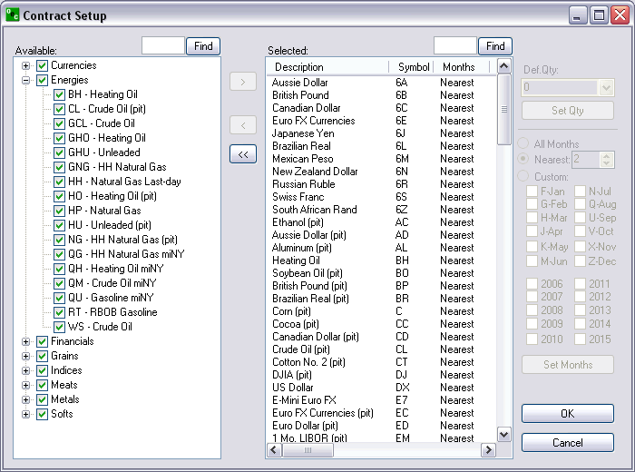
- Next, you will go to “Quotes” in the menu bar and select “Add Market” Select the contract you want to add and click “OK”.

Account Summary
You can customize the "Account Summary" window by hiding the rows that you do not want to see.
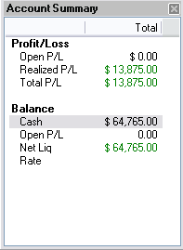
Right-click anywhere inside the Account Summary window then, select "Column Setup..."
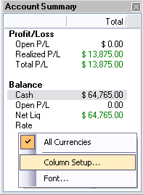
Click on the row that you want to hide under the column "Visibility" and select “hidden”.
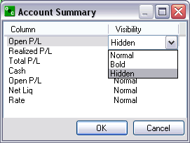
Realized P/L shows the P/L of any closed trades.
Open P/L shows the P/L of any open positions.
Total P/L shows the total P/L for both the Open and Realized P/L.
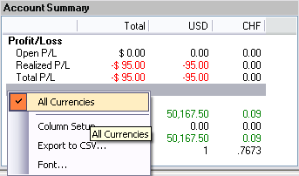
If you have a balance in another currency you will see another window showing the same information for that currency. The window titled “Total” will sum up all the currencies in your account so if you want to view this window only, uncheck “Show Currency Summary Columns”.

Confirmations
As a safeguard a trader can turn on the "Confirmations" feature in E-Futures International. This gives the trader an opportunity to confirm the order before the order is sent for execution. This feature is optional and is turned on by default.
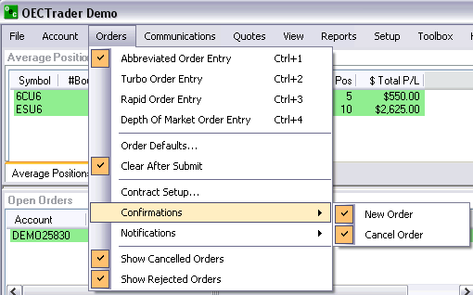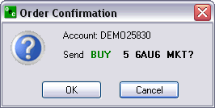

Notifications
If a trader wants to be notified by an alert box when an order has been filled or if an order modification or cancellation failed leave the options checked. We recommend leaving a check mark next to “Notifications” > "Modify or Cancel Failed".
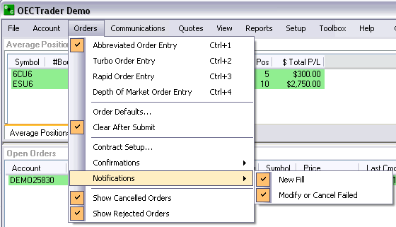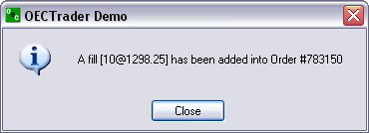

Sound alerts
Customize different sound alerts to make you aware of trading events such as cancel failed, fill received, order accepted etc.
You can customize with any wave (.wav) file or our programmed files which come with the software.
Decide if you would rather hear a sound or see an alert box.
To access Sound Alerts:
- Communications > Sound Alerts
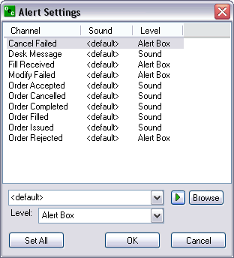
To configure:
- Highlight the channel that you want to assign the sound to.
- Hit "Browse" and search your computer for (.wav) sound files. Note: The default windows .wav files are located: (C:/WINDOWS/Media)
- Hit "Play" to preview the selected sound.
- Level: Set "Alert Box" if you want an alert pop-up along with the sound. Or, select "Sound" if you want sounds only.
- Hit "OK"

Overview

File

Logon
When disconnected from the E-Futures International, selecting Logon will present a dialog box to connect. This will require your Username and Password. As an option you may also select for the E-Futures International to Auto Reconnect in the event you lose connection from the OEC servers. Once the Username and Password have been filled in click Logon to connect or Cancel to abort the process. Note:(Username and Password are case sensitive).
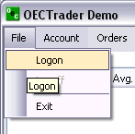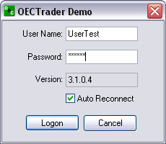

Logoff
To logoff the E-Futures International, select File then logoff. This will present an Exit Confirmation dialog box recapping your daily activity. From this dialog box you can confirm the Exit or Stay Logged On. This selection will keep the E-Futures International on your screen however it will be logged off from the servers.
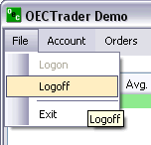

Exit
This feature will provide the same functionality as the Logoff and in addition it will close the entire E-Futures International application.
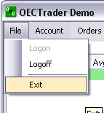
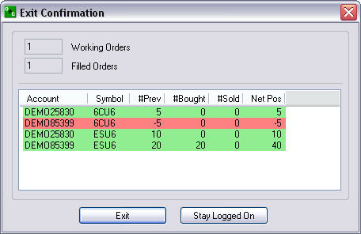

Account
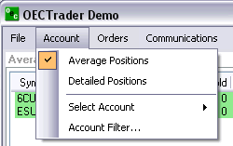

Average positions
Displays the average positions open on each specific contract that has been traded.
In order to go flat in a specific contract:
- In order to go flat in a specific contract, left click on the position and click on "Exit F2". This will immediately transmit a market order for the contract selected to flatten the position.
- In order to go flat in all current contracts with open positions left click the "Exit Al"l. This function will immediately transmit a market order to exit all contracts with open positions.
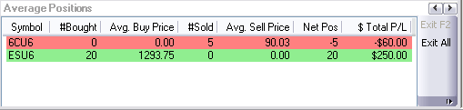

Detailed position
Shows each contract that has been traded specifically. Exit or Exit All the same way as the Average Position window.
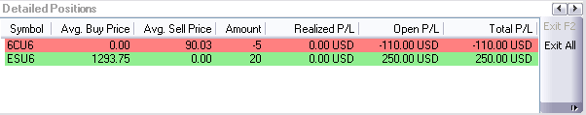

Select Account
If trading multiple accounts, left click the upped area where it says "Account: DEMO85399", choose the account you would like to trade. This same function can be accessed by the keyboard function CTRL-A.
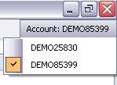

Account Filter
The Account Filter allows the trader to select any account they are assigned to see Open or Completed Orders on the E-Futures International.
Select Always Show Selected Account and the E-Futures International will automatically display the orders of the selected account.
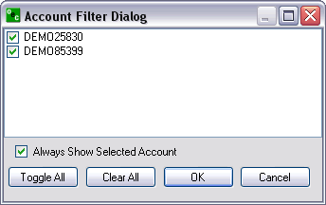

Orders
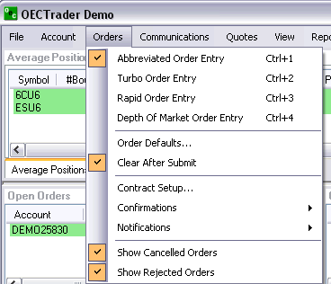

Order Tickets

Abbreviated Order Entry (AOE)
Simple way to trade within the platform
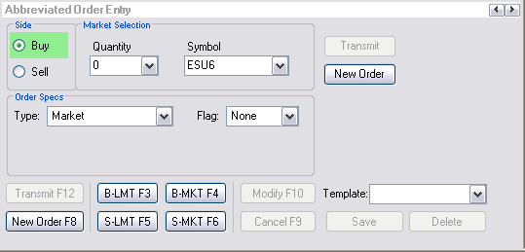

Turbo Order Entry (TOE)
- Create a number of orders at one time
- Can transmit multiple orders concurrently
- Allows you to load and save orders from excel.
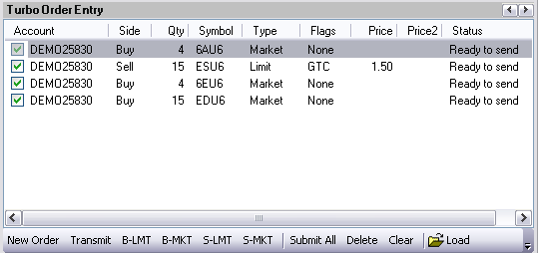

Rapid Order Entry (ROE)
Advanced method to trade with specific amounts and settings.
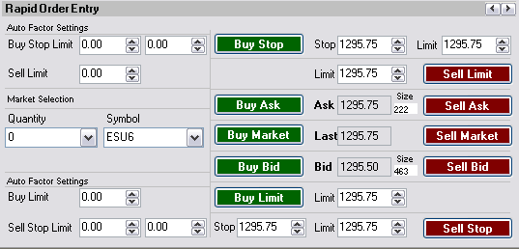

Depth of Market Order Entry (DOM)
Allows you to launch DOMs from here
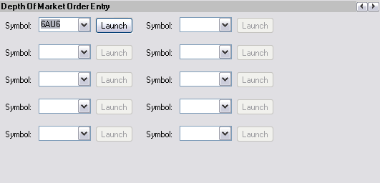

Order default
Can create default orders for each account what will appear when a new order is being placed after clicking on NEW ORDER in the AOE.
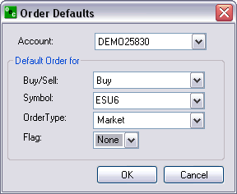

Contract Setup
- Every contract that appears in the SELECTED box will appear in the drop boxes
- Can add market and groups
- Can customize each contract
- Give each contract a default quantity (QTY).
- Change the contract months that are traded.

Confirmations
As a safeguard a trader can turn on the "Confirmations" feature in E-Futures International. This gives the trader an opportunity to confirm the order before the order is sent for execution. This feature is optional and is turned on by default.

Notifications
If a trader wants to be notified by an alert box when an order has been filled or if an order modification or cancellation failed.

Show Orders
To display "Cancelled Orders" and/or "Rejected Orders" in the "Completed Orders" window check the options "Show Cancelled Orders" and/or "Show Rejected Orders" respectively.
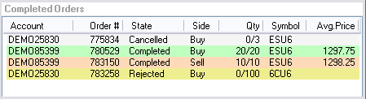

Communications

Sound alert
- Customize different alerts to make you aware of trading events such as cancel failed, fill received, order accepted etc.
- You can customize with any .wav file or our programmed files which come with the software
- Decide if you would rather hear a sound or see an alert box.

Message History
- See your message with the broker you spoke with, when about what and what the broker said.
- Click on view to view within the software or PDF to export into a PDF file or Excel to export into a .exe file
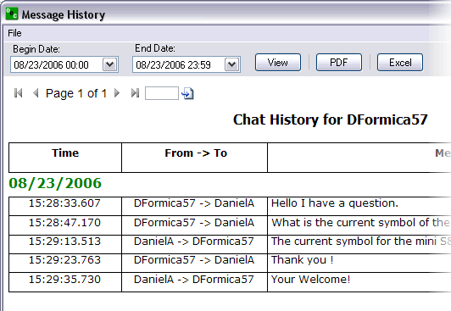

Chat/Research Windows

Close/Open
Click on the RESEARCH options; if the option has a check next to it then it’s available to view; if it doesn’t have a check then it isn’t available to view.
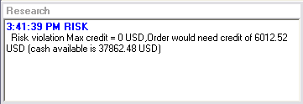
Click on the CHAT option. If it is already checked it will uncheck the CHAT option and it’ll be unavailable to chat.
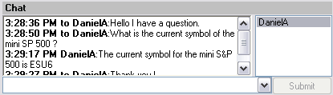

Quotes
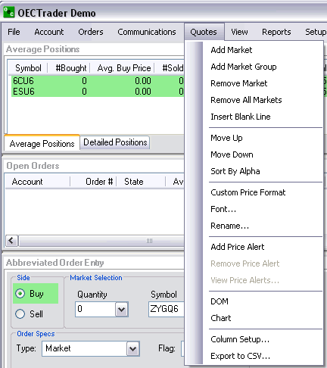

Add Remove Market and Group

Add Market
- Add a market by contract
- Pit contracts are snap-shots
- Electronic contracts are streaming
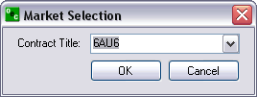

Add Market Group
- Add an entire Market Group
- Nearest month or all months
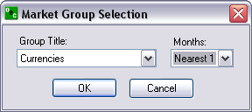

Remove Market
Remove the highlighted market from the Quotes window.

Remove All Markets
Remove all markets from quote window.

Customize Appearance
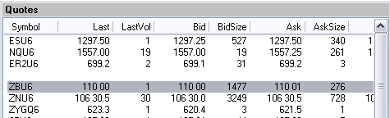

Insert Blank Line
Insert blank line just above the highlighted contract in the Quotes window.

Move up/Move Down
Move the highlighted contract up/down

Sort by Alpha
Sort all the contracts in the Quotes window in alphabetic order

Customize Format

Custom Price Format
Allows customers to change the decimal format of LAST, BID and ASK columns within the Quotes window.
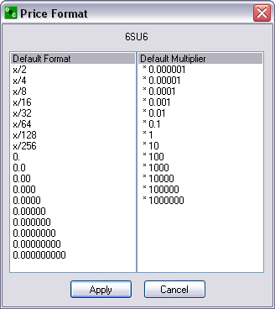

Font
Customize the font of your Quotes window.

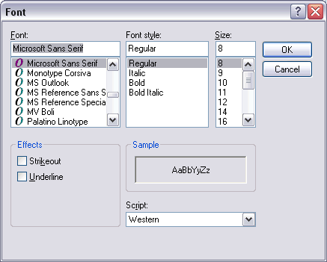

Rename...
Ability to rename the title of the Quotes window.
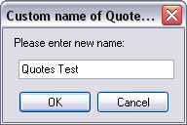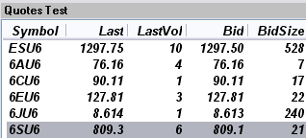

Quote alerts

Add,Remove Price Alert
To add an alert, select the desired contract from the Quotes window. Select "Add Price Alert" to get to the below window. Enter Alert Price, criteria and the options text.
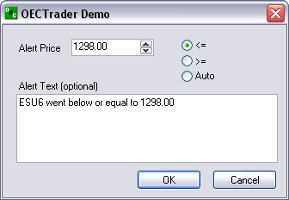
To remove an alert, select the desired contract from Quotes window. Right click and select "Remove Price Alert".

View Price Alerts...
View all current price alerts. To remove one alert, select one alert and hit "Remove". To remove all alerts, just hit "Remove All".
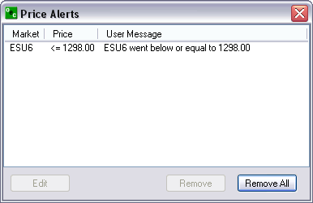

View
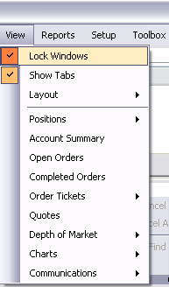

Lock/Unlock Windows
- Click on View, and then LOCK WINDOWS. When a check is next to LOCK WINDOWS then the windows will stay in the current location and are not configurable.
- If there isn’t a check next to the LOCK WINDOWS option the windows are unlocked. Please configure as desired.

Layout

Save...
Save an already customized layout. Enter a name for the layout and hit "OK".
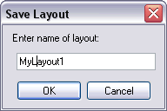
Once the layout is saved it will be available under View > Layouts.
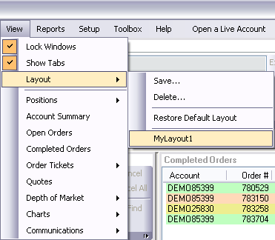

Delete...
Delete a saved layout. Select the layout that you want to delete and hit "OK".

Configure windows

Positions Window
Ability to toggle back and forth from Average Positions to Detailed Positions.
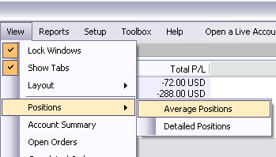

Other Windows
Account Summary, Open Orders, Completed Orders, , Order Tickets, Quotes, Depth of Market, Charts or Communications.

Access Reports
Each report can be filtered by one account or all and date ranges. They can be viewed in PDF or Excel format. Access any one of the following reports.

Daily Fills
Shows the daily fills for the designated dates indicated above.

Daily Activity
Daily Activity is the number and contracts that you traded on the dates indicated above.

Working Orders
Working orders are the orders that are working or have been working from the date increment from above.

Rejected Orders
This report indicates all the rejected orders within the dates entered above.

Order Statistics
The number of orders placed, orders cancelled, orders filled, open orders, the number bought and the number sold for the date above and within the contracts that were traded.

Order Ticket Statistics
The method the orders were placed weather they be AOE, Turbo, Rapid or DOM and the order statistics for each order method.

P/L Summary
The Profit and Loss for each trade placed and the order statistics, for the date(s) provided above.

Chat History
The chat history is recorded for quick reference and for security reason. This allows traders and brokers to view previous conversations between trader and broker.

News History
The Research comments that have been presented by the Brokers to the entire OEC population. These messages are important details from the broker involving major Futures issues.

Order Details
Provides a detailed description of each trade made and the necessary identifications for each detail within the order placed.

Daily Positions
Daily Positions represents the positions for the account above between the dates indicated.

Trade Log
Provides a detailed description of the trades placed. The trade log provides the time, side, the contract, the price and the amount at which each trade was place.

Open Orders
Provides the list of open orders that exist with in that account.

Setup

Shortcut Manager
Allows you to customize the hotkeys for a vast amount of E-Futures International Trading options.
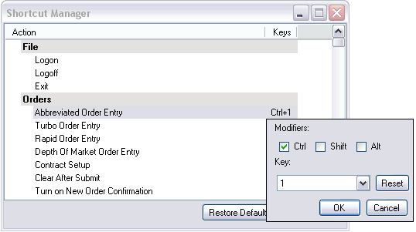

Quick Start
Allows you to view the quick start menu which has a direct link to the Quick Start Guide, Depth user’s guide and all the contact info for customer service and support.
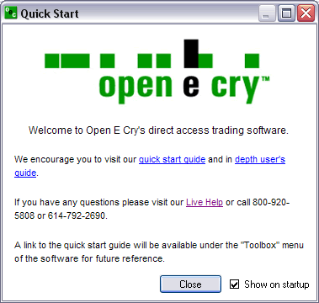

Toolbox

Contract List
Display the Open E Cry's Contract List web page with your default browser.
URL: http://www.openecry.com/platforms/available.cfm

Contract Margins
Display the Open E Cry's Contract Margins web page with your default browser.
URL: http://www.openecry.com/traderstoolbox/margins.cfm

Contract Specs
Display the Open E Cry's Contract Specifications web page with your default browser.
URL: http://www.openecry.com/traderstoolbox/contract.cfm

Glossary
Display the Open E Cry's Glossary web page with your default browser.
URL: http://www.openecry.com/traderstoolbox/glossary.cfm

Help

Contact Us
Display the Open E Cry's Contact web page with your default browser where you can direct questions/comments to our staff.
URL: http://www.openecry.com/company/contact.cfm

About
Displays the current information of the platform that the trader is currently running.
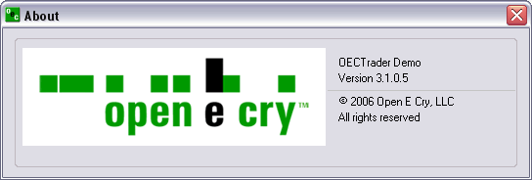

Open Live Account (DEMO ONLY)

Demo Only
Display the Open E Cry's Online Application with Electronic Signature web page with your default browser.
URL: https://www.openecry.com/openaccount/applyonline.cfm

File

Logon
When disconnected from the E-Futures International, selecting Logon will present a dialog box to connect. This will require your Username and Password. As an option you may also select for the E-Futures International to Auto Reconnect in the event you lose connection from the OEC servers. Once the Username and Password have been filled in click Logon to connect or Cancel to abort the process. Note:(Username and Password are case sensitive).

Logoff
To logoff the E-Futures International, select File then logoff. This will present an Exit Confirmation dialog box recapping your daily activity. From this dialog box you can confirm the Exit or Stay Logged On. This selection will keep the E-Futures International on your screen however it will be logged off from the servers.

Exit
This feature will provide the same functionality as the Logoff and in addition it will close the entire E-Futures International application.

Account

Average positions
Displays the average positions open on each specific contract that has been traded.
In order to go flat in a specific contract:
- In order to go flat in a specific contract, left click on the position and click on EXIT F2. This will immediately transmit a market order for the contract selected to flatten the position.
- In order to go flat all current contracts with open positions left click the Exit All. This function will immediately transmit a market order to exit all contracts with open positions.

Detailed position
Shows each contract that has been traded specifically. Exit or Exit All the same way as the Average Position window.

Select Account
If trading multiple accounts, the trader has the ability to switch from one account to the other to trade.
- Left-click the upper right area where the current account number is being displayed. Or, Keyboard function CTRL-A
- Check the account that you want to trade.

Account Filter
The Account Filter allows the trader to select any account they are assigned to see Open or Completed Orders on the E-Futures International.
Select Always Show Selected Account and the E-Futures International will automatically display the orders of the selected account.

Orders

Order Tickets

Abbreviated Order Entry (AOE)
Simple way to trade within the platform.

Side

Buy
Purchase a certain commodity at a certain date in the future at a pre-set price. The future date is called the delivery date. The pre-set price is called the futures price. The price of the commodity on the delivery date is called the settlement price. The futures price, naturally, converges towards the settlement price on the delivery date.

Sell
Sell a certain commodity…

Market Selection

Quantity
Amount of contracts you desire to trade.

Symbol
Code by which futures are identified on a futures exchange; a corporation which provides the facilities to trade futures contracts

Order Specs

Type

Market (MKT)
Orders to buy/sell at the best possible price as soon as possible. They are the first orders to be filled at any given price, and are used to enter or exit the market quickly, regardless of the current price.

Limit (LMT)
Orders generally used to buy/sell at a specified price, or better. They don’t move once the limit price has been reached, i.e., they do not become MKT orders.

Stop (STP)
Orders are traded only when the MKT price trades at or “through” the STP price.
- Buy STP orders is placed above the current MKT price and is transformed into a MKT order when the futures price trades or is bid at or above the STP price
- Sell STP order is placed below the current MKT price, and is transformed into a MKT order when the futures price is traded or is offered at or below the stop price

Stop Limit (STP LMT)
Orders are used like STP orders, but execution is restricted to the limit price or better. They do not become MKT orders once the STP price has been reached. No order can be guaranteed an execution.
- Buy STP LMT is activated when the commodity is bid or traded at or above the STP level, the order will not be filled unless the price remains at or drops below the limit level
- Sell STP LMT is activated when the commodity is offered or traded at or below the STP level, the order will not be filled unless the price remains at or rises above the limit level

Market If Touched (MIT)
Similar to STP orders in two ways:
- They are activated when the price reaches the order level
- They become MKT orders once they are activated
MIT orders are used differently from STPs.
Buy MIT below the MKT price to establish a long position.
Sell MIT above the MKT price to establish a long position.
MIT orders are not allowed on CBOT but are used on CME.

Market To Limit (MKT2LMT)

Market On Open (MOO)
A buy or sell order in which the broker is to execute the order at the market's opening. It does not guarantee the trade will be executed at the listed opening price, but the trade will be executed within a range of prices, or not at all.

Market On Close (MOC)
A buy or sell order which is to be executed as a market order as close as possible to the end of the day.

Market On Pit Open (MOOPit)
This order type is similar to the MOO however it only applies to electronic contracts that have corresponding pit contracts.
Electronic contracts can be placed MOOPit if traders want the contract to be traded at the opening of the Pit for the corresponding pit contracts opening.
i.e. ES has a next day opening of 4:30 EST but if a trader places a MOOPit type then the order will be placed when the S&P opens at 9:30 am EST

Market On Pit Close (MOCPit)
This order type is similar to the MOC however it only applies to electronic contracts that have corresponding pit contracts.
Electronic contracts can be placed MOCPit if traders want the contract to be traded at the closing of the Pit for the corresponding pit contracts close.

Trailing Stop Loss (TrSTP)
A complex stop-loss order in which the stop loss price is set at some fixed percentage below the market price. If the market price rises, the stop loss price rises proportionately, but if the stock price falls, the stop loss price doesn't change. This technique allows an investor to set a limit on the maximum possible loss without setting a limit on the maximum possible gain, and without requiring paying attention to the investment on an ongoing basis.

Trailing Stop Limit (TrSTP LMT)
Place a TrSTP which is a complex stop-limit order in which the stop limit price is set at some fixed percentage above or below the market price. If the market price falls or rises, the stop loss price fall or rise proportionately, but if the stock price rises or falls, the stop limit price doesn't change. This technique allows an investor to set a limit on the maximum possible loss without setting a limit on the maximum possible gain, and without requiring paying attention to the investment on an ongoing basis.
Once the TrSTP has been activated at or above/below depending on the SIDE the commodity was traded; the order will not be filled unless the price remains at or drops/rises in relation to the LMT level.

Flag

Good Till Cancelled (GTC)
Order remains on the books until cancelled and can be filled at an undesirable time if forgotten

Fill or Kill (FOK)
LMT orders which, if not filled immediately, are cancelled

Immediate or Cancel (IOC)
LMT orders which, if not filled immediately, are cancelled

AON

Hot Keys

Template
Have the ability to create a template for quick and easy trading of specific contracts

Save/Delete.
- i.e., BUY the ES at 5 QTY with MKT type and GTC flags. Click on save and when this template is referenced to it will ALWAYS appear as above: BUY 5 ES MKT GTC
- Traders can have as many Templates as desired for quick an easy trading made for the trader.
- You can have different template for the same contract.
- DELETE refers to the template that is highlighted in the REMOVE TEMPLATE drop box. This feature is nice if you have increased your volume and desire to revise your old template.

Transmit/New Order

Exit MKT
- In order to EXIT (F2) a Position quickly, traders are able to highlight the position they wish to exit, and select EXIT or hotkey (F2).
- Once EXIT has been activated the AOE box will display the exiting trade for that position in order to make it FLAT. Click on Transmit and the exiting trade will be placed.

Trade Contract
- Place a trade by clicking TRANSMIT
- Remove the current order information for a new trade by clicking NEW ORDER.

Turbo Order Entry (TOE)
- Create a number of orders at one time
- Can transmit multiple orders concurrently
- Allows you to load and save orders from excel.

Side
Buy/Sell a certain commodity at a certain date in the future at a pre-set price. The future date is called the delivery date. The pre-set price is called the futures price. The price of the commodity on the delivery date is called the settlement price. The futures price, naturally, converges towards the settlement price on the delivery date.

Qty
Amount of contracts you desire to trade.

Symbol
A future symbol is a code by which futures are identified on a futures exchange; a corporation which provides the facilities to trade futures contracts

Type

MKT
Orders to buy/sell at the best possible price as soon as possible. They are the first orders to be filled at any given price, and are used to enter or exit the market quickly, regardless of the current price.

LMT
Orders generally used to buy/sell at a specified price, or better. They don’t move once the limit price has been reached, i.e., they do not become MKT orders

STP
- Orders are traded only when the MKT price trades at or “through” the STP price
- Buy STP orders is placed above the current MKT price and is transformed into a MKT order when the futures price trades or is bid at or above the STP price
- Sell STP order is placed below the current MKT price, and is transformed into a MKT order when the futures price is traded or is offered at or below the STP price

Price
The factor at which you want the order to be placed in regards to the current price. i.e., ES MKT price is 1299.5; PRICE will be placed 1.5 ticks above/below that current price . The Price will be placed above or below the MKT price depending on the SIDE you trade on.

Price2
PRICE 2 is only used if two prices are necessary for a trade. i.e., If a customer were to BUY 5 ES STP LMT PRICE would be 1.5 ticks above the MKT and .5 Ticks below the PRICE once the STP has been reached

Status
1. Confirms what key pieces of information are needed in order to complete an accurate trade
2. Will say READY TO SEND if the order ticket has been completed

Toolbar/Hot Key

Transmit/new order
- Place a trade by clicking TRANSMIT
- Remove the current order information for a new trade by clicking NEW ORDER.

Submit All
Enter a variety of trades manually or load from excel and place all the orders at the same time

Delete/clear
- DELETE will remove the highlighted order entry
- CLEAR will remove ALL order entries

Load/Save
- Load from .csv files or from .exe file types.
- Save the order entries to .csv files or .exe file types

Rapid Order Entry (ROE)
Advanced method to trade with specific amounts and settings.

Auto Factor Settings

Buy Stop Limit
- Orders are used like STP orders, but execution is restricted to the limit price or better. They do not become MKT orders once the STP price has been reached
- Buy STP LMT is activated when the commodity is bid or traded at or above the STP level, the order will not be filled unless the price remains at or drops below the limit leve
- No order can be guaranteed an execution

Factors
The values that you wish to increase your STP order by, i.e., .50 in the first box will increase the STP value by the factor of .50; The same concept works the second factor box in that it effects the LMT.

BUY STOP
Places the STP LMT prices for the buy STP LMT order

Stop
Buy STP orders is placed above the current MKT price, but is not transformed into a MKT order when the futures price trades or is bid at or above the STP price; It turns into a LMT order

Limit
LMT order is placed used to buy/sell at the specified price. It doesn’t move once it has been reached, i.e., it does not become MKT order

Sell Limit

Factors
The price at which you want to place the Sell LMT

SELL LIMIT
Limit
1. A limit order is an order to buy or sell a commodity at a specific price
2. Can only be executed at the limit price or higher

Market Selection

Quantity
Amount of contracts you desire to trade for the entire ROE

Symbol
- A future symbol is a code by which futures are identified on a futures exchange; a corporation which provides the facilities to trade futures contracts
- Is the contract that is traded for the entire ROE

BUY ASK/SELL ASK

BUY ASK
Bid on a commodity at the ASK price

SELL ASK
Sell a commodity at the ASK price

Ask
The ASK price (Offer). The lowest price at which someone is prepared to sell a commodity

Size
The number of sellers at the ask price

BUY MARKET/SELL MARKET
- Will buy a contract of the ROE’s QTY at the MKT price of the ROE’s symbol or
- Will sell a contract of the ROE’s QTY at the MKT price of the ROE’s symbol.

Last
The price at which the ROE’s symbol was last traded

BUY BID/SELL BID

BUY BID
Bid on a commodity at the BID price

SELL BID
Sell a commodity at the BID price

Bid
Bid Price is the highest price at which someone is prepared to buy a commodity

Size
The number of buyers at the bid price

Auto Factor Settings

Buy Limit

Factors
The value that effects where the LMT order will be placed, i.e., 1.5 will place a LMT 1.5 below the LAST price

BUY LIMIT
Limit: LMT order is placed used to buy/sell at the specified price. It doesn’t move once it has been reached, i.e., it does not become MKT order.

Sell Stop Limit
- Orders are used like STP orders, but execution is restricted to the limit price or better. They do not become MKT orders once the STP price has been reached
- Sell STP LMT is activated when the commodity is offered or traded at or below the STP level, the order will not be filled unless the price remains at or rises above the limit level.
- No order can be guaranteed an execution

Factors
- The values that you wish to decrease your STP order by, i.e., .50 in the first box will decrease the STP value by the factor of .50;
- The same concept works the second factor box in that it effects the LMT

SELL STOP
Places the STP LMT prices for the sell STP LMT order

Stop
- Sell STP order is placed below the current MKT price, but is not transformed into a MKT order when the futures price is traded or is offered at or below the STP price; turns into a LMT order.

Limit
- LMT order is used to buy/sell at the specified price. It doesn’t move once it has been reached, i.e., it does not become MKT order
- Can only be executed at the limit price or higher.

Depth of Market Order Entry (DOM)

Depth of Market Order Entry (DOM)
To view the Depth of Market Order Entry go to "Orders" > "Depth Of Market Order Entry"

Open
To open a DOM window from the Depth Of Market Order Entry:
Select the contract symbol from the drop down then hit "Launch".

View
To open a new DOM, go to "View" > "Depth of Market" > "New..."
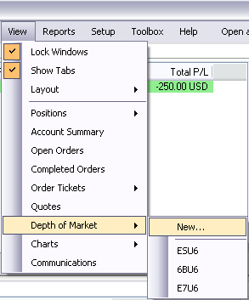
- The only contracts that will appear in the drop box are those that have been specified in the "Contract Setup..." under Orders
- Select the account and contract you wish to trade the DOM and hit "OK".
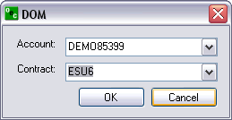
To open a DOM session, go to "View" > "Depth of Market" > i.e:" ESU6". Contracts below the brake Line are contracts you have opened before or are on the default layout.
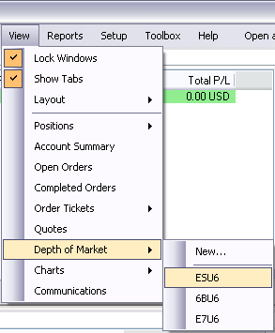

Quotes
Right-click on the contract within QUOTES and scroll down to DOM, click on it and a DOM will appear for the quote you have highlighted.
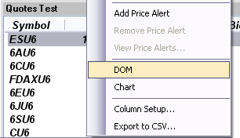

DOM - Opening

Quotes box
Right-click on the contract within Quotes window and select "DOM" in the submenu and a DOM will appear for the quote you have highlighted.

View
Contracts below the brake line are contracts you have opened or are on the default layout. Select any one of these contracts to open the respective DOM.

Depth of Market Order Entry
Main menu "Orders" > "Depth of Market Order Entry"

Charts
Open chart a of the DOM contract you have open currently.
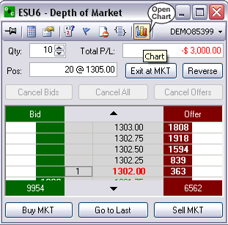

Bid
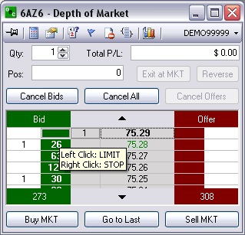

Right Click: STP
- Right click in the green column at the price level you would like to place a buy STPLMT
- The QTY of the buy STP will appear in the white column next to the price level selected

Left Click: LMT
- Left click in the green column at the price you would like to place a buy LMT
- the QTY of the working order will appear in the white column to the left of the selected price

Offer
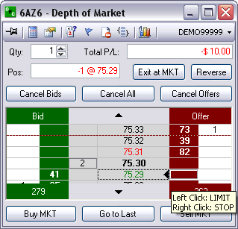

Right Click: STP
- Right click in the red column at the price you would like to places a sell STP
- The QTY of the working order will appear in the white column to the right of the price selected

Left Click: LMT
- Left click in the red column at the price you would like to place a sell LMT
- The qty of the working order will appear white column to the right of the price selected

Modify Price/Quantity of an Order

Price of an Order
- Place the initial order by left clicking in the green column at the price you would like to place a buy limit
- To modify the price left click the order and drag and drop it to the new price
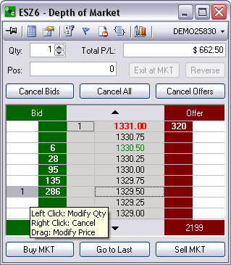

Quantity of an Order
- Place the initial order by i.e., left clicking in the red column at the price you would like to place a sell LMT
- To modify the QTY left click the original order and select a new QTY from the pop out box
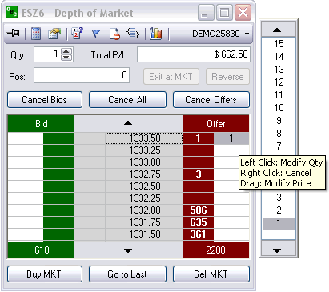

Thumbtack

Stay on Top
To make the DOM ticket stay on top of other applications left click on the Thumbtack so it is pointing straight into the ticket. To allow the DOM to move behind other applications left click the thumb tack again so it is sideways
When the Thumbtack is pointed out to the left this means the STAY ON TOP feature is not active.
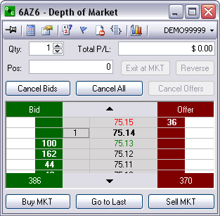
When the Thumbtack is pushed in the STAY ON TOP feature is active and will stay on top of all other applications.
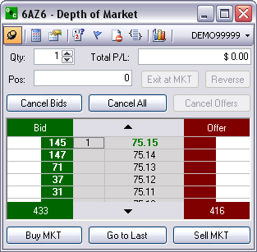

Display Options

Auto Center Price
This Options keeps the MKT prices in the center of the viewable length of the DOM

Open Order Stats
Provides the total number of open orders for each SIDE at the bottom of each column.

Auto Sum Bid/Ask
- Adds up the total Volume traded for the BID and OFFER and displays it at the bottom of the respective columns
- Open Order Stats and Auto Sum Bid/Ask CAN NOT be active at the same time

Open P/L
Open P/L represents the amount of Profit and Loss when the open position exists. If Open P/L is not checked then the Total P/L will show. The Total P/L represents the whole profit and loss from all your trades in that DOM.

Open Pos Price
Your open positions average price will be displayed by an arrow. You will see it displayed on the Offer if you are short and on the Bid if you are long.

Show Tooltip
This options is for first time users of a Depth of Market order ticket. The tooltip allows traders to see what type of order they can place and where they can place it on the DOM
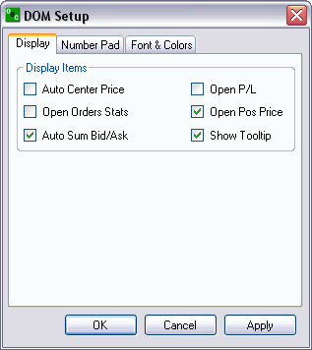

Number Pad
- Configure the number pad to the amounts you desire to have in each key punch options
- Click apply and the Number pad will change without having to reload the Number Pad
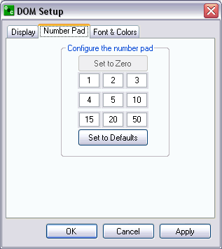

Font & Colors
- Allows Traders to change the DOM and the colors of the orders
- OCO’s, Stops, and Trailing Stops can be customized to their own recognizable color for easy view and quick reference.
- The option to restore the defaults is available if the color scheme does not work for the trader
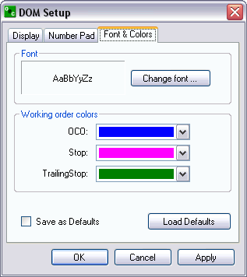

Red/Green Indicator
We have also added the high and low of the launched contract to the DOM order ticket. The high of the day is displayed by a red line and the low is displayed by a green line.

Number Pad

Touch Pad
Number pad is able to be opened and closed with the options at the top of the page that looks like a number pad.
You can change the number template within Display.
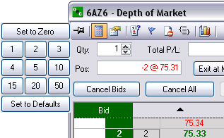

OCO Orders

Order Cancel Order (OCO)
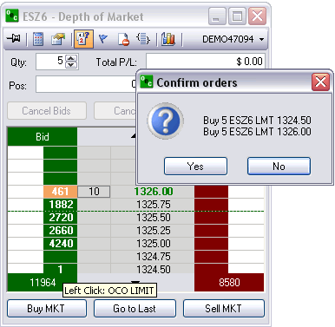
- OCO (One cancels other) is a pair of orders sent together.
- Currently only Limit and Stop orders of one side (buy limit/buy stop or sell limit/sell stop) are supported.
- To send OCO orders, user needs to check OCO toolbar button, and then send two orders in usual way. Another way to enter a single pair of OCO orders, user could hold SHIFT key while clicking.
- After clicking first order, the price would be marked with different color, until second order is entered. To cancel OCO order entry after first order is entered, user should uncheck OCO toolbar button (or release SHIFT key).
- Working OCO orders are displayed in blue color by default.

Order Flags
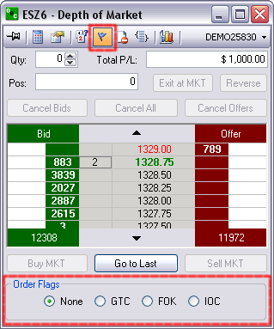

Good Till Cancelled (GTC)
Order remains on the books until cancelled and can be filled at an undesirable time if forgotten

Fill or Kill (FOK)
LMT orders which, if not filled immediately, are cancelled

Immediate or Cancel (IOC)
LMT orders which, if not filled immediately, are cancelled

Stop Limit/Trailing Stop

Stop Limit (STP LMT)
- Orders are used like STP orders, but execution is restricted to the limit price or better. They do not become MKT orders once the STP price has been reached
- Buy STP LMT is activated when the commodity is bid or traded at or above the STP level, the order will not be filled unless the price remains at or drops below the limit level
- Sell STP LMT is activated when the commodity is offered or traded at or below the STP level, the order will not be filled unless the price remains at or rises above the limit level
- No order can be guaranteed an execution
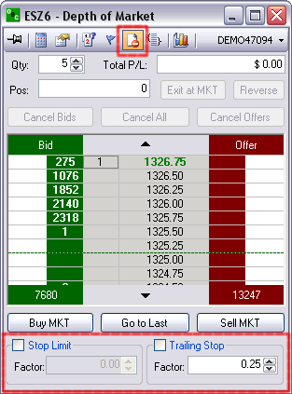

Trailing Stop
A complex stop-loss order in which the stop loss price is set at some fixed percentage below the market price. If the market price rises, the stop loss price rises proportionately, but if the stock price falls, the stop loss price doesn't change. This technique allows an investor to set a limit on the maximum possible loss without setting a limit on the maximum possible gain, and without requiring paying attention to the investment on an ongoing basis.

Bracket Options
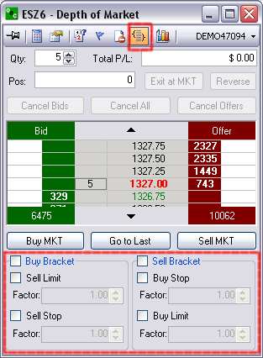

Buy Bracket
1. Bracket orders are designed to limit your loss and lock in a profit by "bracketing" an order with two opposite-side orders.
2. A BUY order is bracketed by a high-side sell limit order and a low-side sell stop (or stop-limit) order.

Sell Bracket
1. Bracket orders are designed to limit your loss and lock in a profit by "bracketing" an order with two opposite-side orders
2. A SELL order is bracketed by a high-side buy stop (or stop-limit) order and a low side buy limit order.

Account Filter
Scroll through various accounts you might have and trade the same contract with a click of a button.
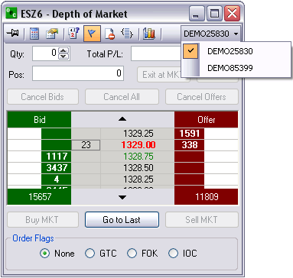

Qty
Amount of contracts you desire to trade for the entire ROE.
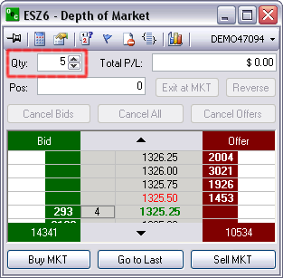

P/L

Open P/L or Current P/L
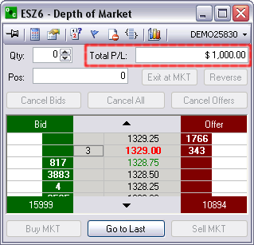
1. Open P/L is the Profit and Lose for the Position that is open currently
2. Current P/L is the Profit and Lose for all positions that have been traded on this session

Position
Shows the amount of contracts you have open and at what price they are open at.
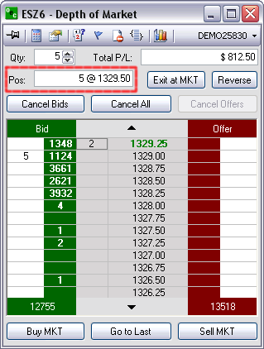

Exit at MKT
Turns any open position into a FLAT position by trading the opposite of the open position.
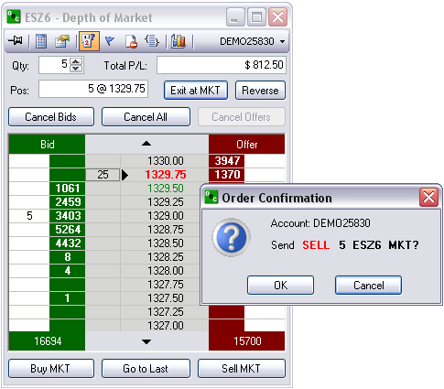

Reverse
Will take any open position and EXIT it and then reverse the position by placing the identical position on the reverse side. it was initially open on.
i.e., ES 1 @ 1329.75 and reverse the position it would end up ES -1 @ 1329.75
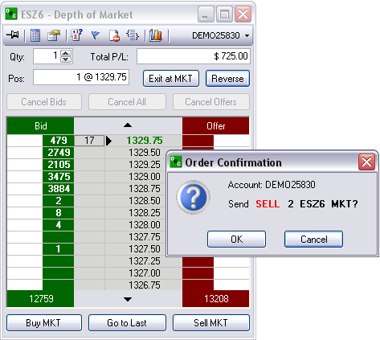

Cancel orders
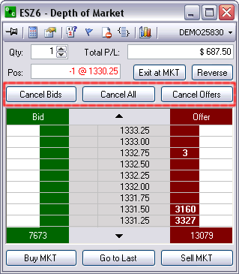

Cancel Bids
This options will cancel out of all working orders on the BID side

Cancel All
This will cancel ALL working orders

Cancel Offers
Will cancel out of all working orders on the OFFER side

At Market
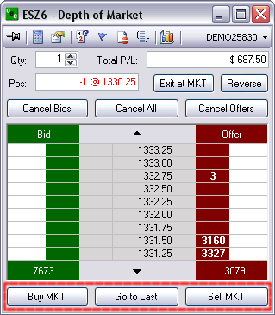

Buy MKT
Place a Buy @ MKT at the bid price

Go to Last
Will center the MKT Prices; without having to scroll; if they have trailed off the existing view

Sell MKT
Will place a Sell @ MKT at the offer price

Order Default
Can create default orders for each account which will appear when a new order is being placed after clicking on NEW ORDER in the AOE.
- Go to "Orders" > "Order Defaults..."
- Enter your default parameters and hit "OK"

Contract Setup
- Every contract that appears in the "Selected" box will appear in your drop down lists for the order tickets and quotes window setup.
- Click on the desired group (i.e.) “Currencies” under the "Available" window and open it up so that you can see all of the contracts included in that window. Click to add a checkmark next to the contracts you want to see in your drop down lists for the order tickets and quotes window setup. You will see the contracts move to the “Selected” box as you select them.
- Once you have added the desired contracts to the contract setup “Selected” box you will next want to select the months that you want to trade. If you change the month’s column to the “Nearest 2” selection you will most likely have the contract months you trade. If the month you trade is not part of the Nearest 2 selection then select “All Months”. Make sure that you click “Set Months” before exiting the “Contract Setup” window or else your settings will not be saved.
- You can also set a default quantity for one or many contracts at once by pressing CTRL and selecting the contracts then, set the Def. Qty. and hit "Set Qty". Note: This settings will show once you log off and log back in.
- Next, you will go to “Quotes” in the menu bar and select “Add Market” Select the contract you want to add and click “OK”.

Confirmations
As a safeguard a trader can turn on the "Confirmations" feature in E-Futures International. This gives the trader an opportunity to confirm the order before the order is sent for execution. This feature is optional and is turned on by default.

Notifications
If a trader wants to be notified by an alert box when an order has been filled or if an order modification or cancellation failed leave the options checked. We recommend leaving a check mark next to “Notifications” > "Modify or Cancel Failed".

Show Orders
To display "Cancelled Orders" and/or "Rejected Orders" in the "Completed Orders" window check the options "Show Cancelled Orders" and/or "Show Rejected Orders" respectively.

Communications

Sound alerts
Customize different sound alerts to make you aware of trading events such as cancel failed, fill received, order accepted etc.
You can customize with any wave (.wav) file or our programmed files which come with the software.
Decide if you would rather hear a sound or see an alert box.
To access Sound Alerts:
- Communications > Sound Alerts
To configure:
- Highlight the channel that you want to assign the sound to.
- Hit "Browse" and search your computer for (.wav) sound files. Note: The default windows .wav files are located: (C:/WINDOWS/Media)
- Hit "Play" to preview the selected sound.
- Level: Set "Alert Box" if you want an alert pop-up along with the sound. Or, select "Sound" if you want sounds only.
- Hit "OK"

Message History
See your message history in detail of all previous chat sessions you have had with the brokers.
Click on "View" to view within the software or PDF to export into a PDF file or Excel to export into a .exe file.

Chat
Allows one customer to directly ask questions, get quotes, place orders, etc with a broker. The broker answers the questions/comments via the CHAT box.
We highly recommend most questions be transmitted via the CHAT box. It is the most streamline method of communication.
In order to initiate chat with a BROKER, select their name (i.e. OECBroker9) and type your message in the open row at the bottom. Once you have entered your text you will be offered the SUBMIT button. Click on the SUBMIT button and the broker you selected will receive your message. The drop box is there for your reference so you can repeat your self with previous comments or say the same thing to a different broker by just clicking into the drop box and selected the previously written text.
To access Chat:
- From Communications menu options, click on the CHAT option. If it is already checked it will uncheck the CHAT option and it’ll be unavailable to chat.
- From View menu, click on Chat in order to make it highlighted.

Research
This window displays important messages that consist of major market issues sent from the brokers to the entire OEC population. It also displays Risk messages such as available credit, etc.
Each time a research appears it will be accompanied by a topic first then a message. The broker can make it as specific as possible for quick reference by using the seven templates. The topics are Indices, Currencies, Energies, Grains, Metals, News, and General.
To access Research:
- From Communications menu options, click on the "Research Window"; if the option has a check next to it then it’s available to view; if it does not have a check then it isn’t available to view.
- From View menu, click on Research in order to make it highlighted.

Quotes

Add Market
To add a Market from Quotes window:
Right-click anywhere in the "Quotes" window and select "Add Market"
To add a Market from the main menu:
Main menu, go to "Quotes" > "Add Market"

The Market Selection box will appear. Just select the desired contract and hit "OK".
Notes:
- Add a market by contract
- Pit contracts are snap-shots
- Electronic contracts are streaming

Add Market Group
To add a Market from the Quotes window:
Right-click on the Quotes window and select "Add Market Group".
To add a Market from the Main menu:
Go to "Quotes" > "Add Market Group".

The "Market Group Selection" box will appear. Select the market group and the nearest month or all months.
.

Remove Market
Remove the highlighted market from the Quotes window.
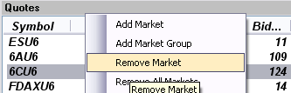
1. To remove a Market:
- Highlight the market in the Quotes window
- Right-click within the Quotes window and select "Remove Market"

2. To remove a Market
- Highlight the market in the Quotes window
- Main menu "Quotes" > "Remove Market"

Remove All Markets
Remove all markets from quote window.
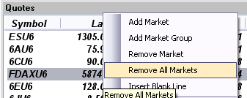
1. To remove all Markets:
- Right-click anywhere in the Quotes window and select "Remove All Markets"

2. To remove all Markets:
- Main menu "Quotes" > "Remove All Markest"

Insert Blank Line
Insert blank line just above the highlighted contract in the Quotes window.
1. To insert a blank line:
- Highlight the contract that you want to have the blank line insert just above
- Right-click and select "Insert Blank Line"

2. To insert a blank line:
- Highlight the contract that you want to have the blank line insert just above
- Main menu "Quotes" > "Insert Blank Line"

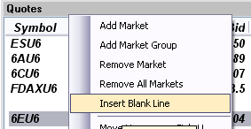

Move up/Move Down
Move the highlighted contract up/down.
To move a contract up/down:
- Highlight the contract in the Quotes window
- Right-click and select "Move Up" or "Move Down"

Sort by Alpha
Sort all the contracts in the Quotes window in alphabetic order.
To sort by alphabetic order:
- Right-click anywhere in the Quotes window and select "Sort by Alpha"

Custom Price Format
Allows customers to change the decimal format of LAST, BID and ASK columns within the Quotes window.

Font
Customize the font of your Quotes window.

Rename...
Ability to rename the title of the Quotes window.
Go to "Quotes" > "Rename...", enter the title name and hit "OK".
The renamed Quotes window title would look like the one below.

Add,Remove Price Alert
To add an alert, select the desired contract from the Quotes window. Select "Add Price Alert" to get to the below window. Enter Alert Price, criteria and the options text.
When the price criteria is met, the alert box is displayed.
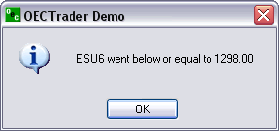

To remove an alert, select the desired contract from Quotes window. Right click and select "Remove Price Alert".

View Price Alerts...
Go to "Quotes" > "View Price Alerts".
To remove one alert, select one alert and hit "Remove". To remove all alerts, just hit "Remove All".

Depth or Market (DOM)
Opens the DOM for a specific contract. Jut highlight a contract from the Quotes window then select "DOM".
Next, the DOM window will open.
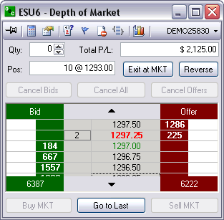

Column Setup
Check the columns that you want visible from the Quotes window. Then, hit "Save" to view your the changes.
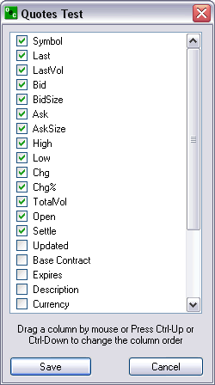

Export to CSV
Exports your Quotes window data to an excel file. After selecting this option you will see a confirmation dialog box.
To export all items just hit "Yes".
To export selected items, you would have to first highlight the desired items from the Quotes window by pressing CTRL left mouse click each item. Then, select the "Export to CSV..." option and hit "No" in the confirmation dialog box.
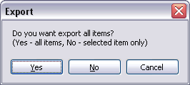

View

Lock/Unlock Windows
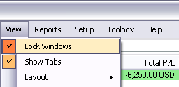
To lock E-Futures International windows:
- Main menu, click on "View" > "Lock Windows".
- When a check is next to "Lock Windows" then the windows will stay in the current location and are not configurable.

To unlock E-Futures International windows:
- Main menu, click on "View" > "Lock Windows" and make sure that there isn't a check next to "Lock Windows"
- Uncheck "Lock Windows" then the windows will become movable and configurable.

Show Tabs
Some of the windows within E-Futures International have tabs available which can be displayed by selecting View > Show Tabs. The tabs will appear below the box they are associated with
Example 1: Positions window has "Average Positions" and "Detailed Positions"
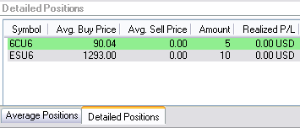
Example 2: Order Tickets window has "Standard", "Turbo", 'Rapid", "DOM".
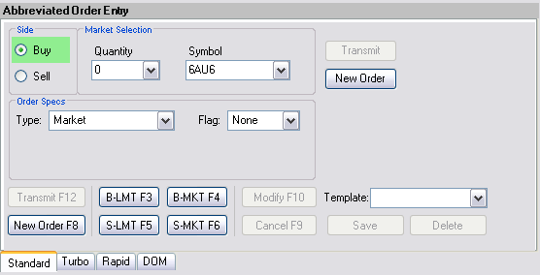

Layout

Layout
Layout offers the ability to save different window configurations and delete existing configurations.
Layout also allows the trader to RESTORE DEFAULT LAYOUT; which is the initial layout that appeared when the software was first downloaded.

Save...
Save an already customized layout. Enter a name for the layout and hit "OK".
Once the layout is saved it will be available under View > Layouts.

Delete...
Delete a saved layout. Select the layout that you want to delete and hit "OK".

Configuring Windows

Docked Windows
To configure that specific window, right-click on any of the boxes to view a menu as the one below.
View information on how to unlock a window.
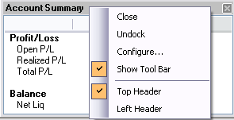

Close
CLOSE will remove the selected box from the layout. This allows traders to configure the trading platform layout. If you wish to re-open that box just simply go to "View" > and the box you wish to open. Once clicked the box will appear UNDOCKED and you will have to manually dock into the Layout (if desired).

Undock
The DOCKED form is the form that appears on the default layout. Each box its nicely compacted within the width and height of the E-Futures International platform. Any undocked boxes will appear as free flowing windows. The UNDOCK feature will remove the selected box from the docked form and display the selected box as a free flowing window.
If a free flowing undocked box is open, when the E-Futures International platform is closed/minimized the free flowing box will close/minimize with it.
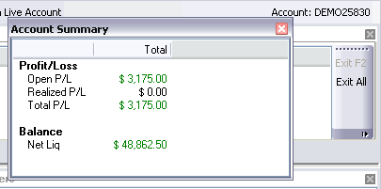

Configure...
See Information.

Show Tool Bar
If the check is next to the "Show Tool Bar", the tool bar will appear within that box. The tool bar offers a number of different options depending on the box selected. Each box has different toolbar options.

Top Header
Display the header on the top of the box running from left to right the entire height of the box.

Left Header
Display the header on the left-side of the box running from top to bottom the entire height of the box.

Undocked Windows
Once the windows are unlocked the ability to change the windows are endless. Perform a mouse right-click on the header of the undocked window to view a menu like the one shown below.
View information on how to lock/unlock windows.
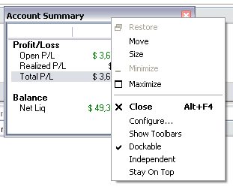

Move
Allow to move the box without activating the blue docking indicator arrows.

Size
Allow to change the size of the box. Same result is obtained by carefully hovering the mouse on one of the borders of the box until the mouse cursor changes to a double-pointed arrow, at this point you would want to left-press your mouse and drag until the desired size is achieved.

Maximize
Maximize the window to the whole size of your screen.

Close
CLOSE will remove the selected box from the layout. This allows traders to configure the trading platform layout. If you wish to re-open that box just simply go to "View" > and the box you wish to open. Once clicked the box will appear UNDOCKED and you will have to manually dock into the Layout (if desired).

Configure...
See Information.

Show Tool Bars
If the check is next to the "Show Tool Bar", the tool bar will appear within that box. The tool bar offers a number of different options depending on the box selected. Each box has different toolbar options.

Dockable
When 'Dockable' is checked, dragging the undocked window will show the the layout configuration tool (blue indicator arrows) which allow to dock the window.

Independent
When 'Independent' is checked, the undocked window will change its look to that of a regular window.

Stay on Top
When 'Stay on Top' is checked, the window will remain visible at all times; it will never be under any other window on your screen.

Docking a Window
Perform a Left-click and leave pressed the header section of the window. Drag the window slowly onto the box you desire to place it, you should see the layout configuration tool (blue indicator arrows) shown in the below image.
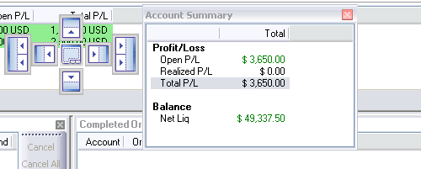
Keep pressing the header of you window, place your cursor over the location in relation to the box that is highlighted. In this case we select the single right options in the layout configuration tool to dock the Account Summary window in its original spot. Or, If you want it to stretch across the bottom place your cursor on the bottom option of the layout configuration tool.

Configure
To configure a window, first make sure that the trader windows are unlocked. View information on how to unlock a window.
Then, place the mouse on the header of the window, perform a right click and select 'Configure...'.
CONFIGURE allows traders to open the specific options for the selected box. Whether it be toolbar options, menu options or general box settings.
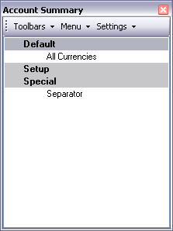

Toolbar
Gives the options to have one or multiple toolbars with various tools within each toolbar. At any time a trade can restore the toolbar to the default layout.

Menu
Offers options to add different utilities into the menu option for each box.

Settings
Provides the ability to change the types of methods traders wish to use the toobar.

Positions

Average positions
Displays the average positions open on each specific contract that has been traded.
In order to go flat in a specific contract:
- In order to go flat in a specific contract, left click on the position and click on EXIT F2. This will immediately transmit a market order for the contract selected to flatten the position.
- In order to go flat all current contracts with open positions left click the Exit All. This function will immediately transmit a market order to exit all contracts with open positions.

Detailed position
Shows each contract that has been traded specifically. Exit or Exit All the same way as the Average Position window.

Account Summary
You can customize the "Account Summary" window by hiding the rows that you do not want to see.
Right-click anywhere inside the Account Summary window then, select "Column Setup..."
Click on the row that you want to hide under the column "Visibility" and select “hidden”.
Realized P/L shows the P/L of any closed trades.
Open P/L shows the P/L of any open positions.
Total P/L shows the total P/L for both the Open and Realized P/L.
If you have a balance in another currency you will see another window showing the same information for that currency. The window titled “Total” will sum up all the currencies in your account so if you want to view this window only, uncheck “Show Currency Summary Columns”.

Open Orders
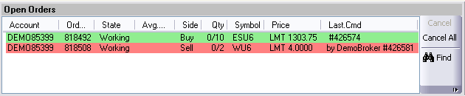
Open Orders allows traders to view their open orders in addition to the order statisitics. At any time a trade can cancel the order by clicking “ Cancel” which will cancel the selected order or “Cencel All” which will cancel all the orders in the Open order box.

Completed Orders
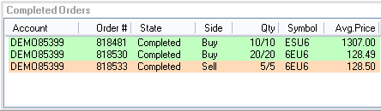
Completed Orders provides traders with an accurate view of their completed trades from the current session. The completed orders is color coordinated for easy viewing and customization. Traders can customize anything from the column setup to the font size by right clicking in the completed orders box area

Order Tickets

Abbreviated Order Entry (AOE)
Simple way to trade within the platform.

Side

Buy
Purchase a certain commodity at a certain date in the future at a pre-set price. The future date is called the delivery date. The pre-set price is called the futures price. The price of the commodity on the delivery date is called the settlement price. The futures price, naturally, converges towards the settlement price on the delivery date.

Sell
Sell a certain commodity…

Market Selection

Quantity
Amount of contracts you desire to trade.

Symbol
Code by which futures are identified on a futures exchange; a corporation which provides the facilities to trade futures contracts

Order Specs

Type

Market (MKT)
Orders to buy/sell at the best possible price as soon as possible. They are the first orders to be filled at any given price, and are used to enter or exit the market quickly, regardless of the current price.

Limit (LMT)
Orders generally used to buy/sell at a specified price, or better. They don’t move once the limit price has been reached, i.e., they do not become MKT orders.

Stop (STP)
Orders are traded only when the MKT price trades at or “through” the STP price.
- Buy STP orders is placed above the current MKT price and is transformed into a MKT order when the futures price trades or is bid at or above the STP price
- Sell STP order is placed below the current MKT price, and is transformed into a MKT order when the futures price is traded or is offered at or below the stop price

Stop Limit (STP LMT)
Orders are used like STP orders, but execution is restricted to the limit price or better. They do not become MKT orders once the STP price has been reached. No order can be guaranteed an execution.
- Buy STP LMT is activated when the commodity is bid or traded at or above the STP level, the order will not be filled unless the price remains at or drops below the limit level
- Sell STP LMT is activated when the commodity is offered or traded at or below the STP level, the order will not be filled unless the price remains at or rises above the limit level

Market If Touched (MIT)
Similar to STP orders in two ways:
- They are activated when the price reaches the order level
- They become MKT orders once they are activated
MIT orders are used differently from STPs.
Buy MIT below the MKT price to establish a long position.
Sell MIT above the MKT price to establish a long position.
MIT orders are not allowed on CBOT but are used on CME.

Market To Limit (MKT2LMT)

Market On Open (MOO)
A buy or sell order in which the broker is to execute the order at the market's opening. It does not guarantee the trade will be executed at the listed opening price, but the trade will be executed within a range of prices, or not at all.

Market On Close (MOC)
A buy or sell order which is to be executed as a market order as close as possible to the end of the day.

Market On Pit Open (MOOPit)
This order type is similar to the MOO however it only applies to electronic contracts that have corresponding pit contracts.
Electronic contracts can be placed MOOPit if traders want the contract to be traded at the opening of the Pit for the corresponding pit contracts opening.
i.e. ES has a next day opening of 4:30 EST but if a trader places a MOOPit type then the order will be placed when the S&P opens at 9:30 am EST

Market On Pit Close (MOCPit)
This order type is similar to the MOC however it only applies to electronic contracts that have corresponding pit contracts.
Electronic contracts can be placed MOCPit if traders want the contract to be traded at the closing of the Pit for the corresponding pit contracts close.

Trailing Stop Loss (TrSTP)
A complex stop-loss order in which the stop loss price is set at some fixed percentage below the market price. If the market price rises, the stop loss price rises proportionately, but if the stock price falls, the stop loss price doesn't change. This technique allows an investor to set a limit on the maximum possible loss without setting a limit on the maximum possible gain, and without requiring paying attention to the investment on an ongoing basis.

Trailing Stop Limit (TrSTP LMT)
Place a TrSTP which is a complex stop-limit order in which the stop limit price is set at some fixed percentage above or below the market price. If the market price falls or rises, the stop loss price fall or rise proportionately, but if the stock price rises or falls, the stop limit price doesn't change. This technique allows an investor to set a limit on the maximum possible loss without setting a limit on the maximum possible gain, and without requiring paying attention to the investment on an ongoing basis.
Once the TrSTP has been activated at or above/below depending on the SIDE the commodity was traded; the order will not be filled unless the price remains at or drops/rises in relation to the LMT level.

Flag

Good Till Cancelled (GTC)
Order remains on the books until cancelled and can be filled at an undesirable time if forgotten

Fill or Kill (FOK)
LMT orders which, if not filled immediately, are cancelled

Immediate or Cancel (IOC)
LMT orders which, if not filled immediately, are cancelled

AON

Hot Keys

Template
Have the ability to create a template for quick and easy trading of specific contracts

Save/Delete.
- i.e., BUY the ES at 5 QTY with MKT type and GTC flags. Click on save and when this template is referenced to it will ALWAYS appear as above: BUY 5 ES MKT GTC
- Traders can have as many Templates as desired for quick an easy trading made for the trader.
- You can have different template for the same contract.
- DELETE refers to the template that is highlighted in the REMOVE TEMPLATE drop box. This feature is nice if you have increased your volume and desire to revise your old template.

Transmit/New Order

Exit MKT
- In order to EXIT (F2) a Position quickly, traders are able to highlight the position they wish to exit, and select EXIT or hotkey (F2).
- Once EXIT has been activated the AOE box will display the exiting trade for that position in order to make it FLAT. Click on Transmit and the exiting trade will be placed.

Trade Contract
- Place a trade by clicking TRANSMIT
- Remove the current order information for a new trade by clicking NEW ORDER.

Turbo Order Entry (TOE)
- Create a number of orders at one time
- Can transmit multiple orders concurrently
- Allows you to load and save orders from excel.

Side
Buy/Sell a certain commodity at a certain date in the future at a pre-set price. The future date is called the delivery date. The pre-set price is called the futures price. The price of the commodity on the delivery date is called the settlement price. The futures price, naturally, converges towards the settlement price on the delivery date.

Qty
Amount of contracts you desire to trade.

Symbol
A future symbol is a code by which futures are identified on a futures exchange; a corporation which provides the facilities to trade futures contracts

Type

MKT
Orders to buy/sell at the best possible price as soon as possible. They are the first orders to be filled at any given price, and are used to enter or exit the market quickly, regardless of the current price.

LMT
Orders generally used to buy/sell at a specified price, or better. They don’t move once the limit price has been reached, i.e., they do not become MKT orders

STP
- Orders are traded only when the MKT price trades at or “through” the STP price
- Buy STP orders is placed above the current MKT price and is transformed into a MKT order when the futures price trades or is bid at or above the STP price
- Sell STP order is placed below the current MKT price, and is transformed into a MKT order when the futures price is traded or is offered at or below the STP price

Price
The factor at which you want the order to be placed in regards to the current price. i.e., ES MKT price is 1299.5; PRICE will be placed 1.5 ticks above/below that current price . The Price will be placed above or below the MKT price depending on the SIDE you trade on.

Price2
PRICE 2 is only used if two prices are necessary for a trade. i.e., If a customer were to BUY 5 ES STP LMT PRICE would be 1.5 ticks above the MKT and .5 Ticks below the PRICE once the STP has been reached

Status
1. Confirms what key pieces of information are needed in order to complete an accurate trade
2. Will say READY TO SEND if the order ticket has been completed

Toolbar/Hot Key

Transmit/new order
- Place a trade by clicking TRANSMIT
- Remove the current order information for a new trade by clicking NEW ORDER.

Submit All
Enter a variety of trades manually or load from excel and place all the orders at the same time

Delete/clear
- DELETE will remove the highlighted order entry
- CLEAR will remove ALL order entries

Load/Save
- Load from .csv files or from .exe file types.
- Save the order entries to .csv files or .exe file types

Rapid Order Entry (ROE)
Advanced method to trade with specific amounts and settings.

Auto Factor Settings

Buy Stop Limit
- Orders are used like STP orders, but execution is restricted to the limit price or better. They do not become MKT orders once the STP price has been reached
- Buy STP LMT is activated when the commodity is bid or traded at or above the STP level, the order will not be filled unless the price remains at or drops below the limit leve
- No order can be guaranteed an execution

Factors
The values that you wish to increase your STP order by, i.e., .50 in the first box will increase the STP value by the factor of .50; The same concept works the second factor box in that it effects the LMT.

BUY STOP
Places the STP LMT prices for the buy STP LMT order

Stop
Buy STP orders is placed above the current MKT price, but is not transformed into a MKT order when the futures price trades or is bid at or above the STP price; It turns into a LMT order

Limit
LMT order is placed used to buy/sell at the specified price. It doesn’t move once it has been reached, i.e., it does not become MKT order

Sell Limit

Factors
The price at which you want to place the Sell LMT

SELL LIMIT
Limit
1. A limit order is an order to buy or sell a commodity at a specific price
2. Can only be executed at the limit price or higher

Market Selection

Quantity
Amount of contracts you desire to trade for the entire ROE

Symbol
- A future symbol is a code by which futures are identified on a futures exchange; a corporation which provides the facilities to trade futures contracts
- Is the contract that is traded for the entire ROE

BUY ASK/SELL ASK

BUY ASK
Bid on a commodity at the ASK price

SELL ASK
Sell a commodity at the ASK price

Ask
The ASK price (Offer). The lowest price at which someone is prepared to sell a commodity

Size
The number of sellers at the ask price

BUY MARKET/SELL MARKET
- Will buy a contract of the ROE’s QTY at the MKT price of the ROE’s symbol or
- Will sell a contract of the ROE’s QTY at the MKT price of the ROE’s symbol.

Last
The price at which the ROE’s symbol was last traded

BUY BID/SELL BID

BUY BID
Bid on a commodity at the BID price

SELL BID
Sell a commodity at the BID price

Bid
Bid Price is the highest price at which someone is prepared to buy a commodity

Size
The number of buyers at the bid price

Auto Factor Settings

Buy Limit

Factors
The value that effects where the LMT order will be placed, i.e., 1.5 will place a LMT 1.5 below the LAST price

BUY LIMIT
Limit: LMT order is placed used to buy/sell at the specified price. It doesn’t move once it has been reached, i.e., it does not become MKT order.

Sell Stop Limit
- Orders are used like STP orders, but execution is restricted to the limit price or better. They do not become MKT orders once the STP price has been reached
- Sell STP LMT is activated when the commodity is offered or traded at or below the STP level, the order will not be filled unless the price remains at or rises above the limit level.
- No order can be guaranteed an execution

Factors
- The values that you wish to decrease your STP order by, i.e., .50 in the first box will decrease the STP value by the factor of .50;
- The same concept works the second factor box in that it effects the LMT

SELL STOP
Places the STP LMT prices for the sell STP LMT order

Stop
- Sell STP order is placed below the current MKT price, but is not transformed into a MKT order when the futures price is traded or is offered at or below the STP price; turns into a LMT order.

Limit
- LMT order is used to buy/sell at the specified price. It doesn’t move once it has been reached, i.e., it does not become MKT order
- Can only be executed at the limit price or higher.

Depth of Market Order Entry (DOM)

Depth of Market Order Entry (DOM)
To view the Depth of Market Order Entry go to "Orders" > "Depth Of Market Order Entry"

Open
To open a DOM window from the Depth Of Market Order Entry:
Select the contract symbol from the drop down then hit "Launch".

View
To open a new DOM, go to "View" > "Depth of Market" > "New..."
- The only contracts that will appear in the drop box are those that have been specified in the "Contract Setup..." under Orders
- Select the account and contract you wish to trade the DOM and hit "OK".
To open a DOM session, go to "View" > "Depth of Market" > i.e:" ESU6". Contracts below the brake Line are contracts you have opened before or are on the default layout.

Quotes
Right-click on the contract within QUOTES and scroll down to DOM, click on it and a DOM will appear for the quote you have highlighted.

DOM - Opening

Quotes box
Right-click on the contract within Quotes window and select "DOM" in the submenu and a DOM will appear for the quote you have highlighted.

View
Contracts below the brake line are contracts you have opened or are on the default layout. Select any one of these contracts to open the respective DOM.

Depth of Market Order Entry
Main menu "Orders" > "Depth of Market Order Entry"

Charts
Open chart a of the DOM contract you have open currently.

Bid

Right Click: STP
- Right click in the green column at the price level you would like to place a buy STPLMT
- The QTY of the buy STP will appear in the white column next to the price level selected

Left Click: LMT
- Left click in the green column at the price you would like to place a buy LMT
- the QTY of the working order will appear in the white column to the left of the selected price

Offer

Right Click: STP
- Right click in the red column at the price you would like to places a sell STP
- The QTY of the working order will appear in the white column to the right of the price selected

Left Click: LMT
- Left click in the red column at the price you would like to place a sell LMT
- The qty of the working order will appear white column to the right of the price selected

Modify Price/Quantity of an Order

Price of an Order
- Place the initial order by left clicking in the green column at the price you would like to place a buy limit
- To modify the price left click the order and drag and drop it to the new price

Quantity of an Order
- Place the initial order by i.e., left clicking in the red column at the price you would like to place a sell LMT
- To modify the QTY left click the original order and select a new QTY from the pop out box

Thumbtack

Stay on Top
To make the DOM ticket stay on top of other applications left click on the Thumbtack so it is pointing straight into the ticket. To allow the DOM to move behind other applications left click the thumb tack again so it is sideways
When the Thumbtack is pointed out to the left this means the STAY ON TOP feature is not active.
When the Thumbtack is pushed in the STAY ON TOP feature is active and will stay on top of all other applications.

Display Options

Auto Center Price
This Options keeps the MKT prices in the center of the viewable length of the DOM

Open Order Stats
Provides the total number of open orders for each SIDE at the bottom of each column.

Auto Sum Bid/Ask
- Adds up the total Volume traded for the BID and OFFER and displays it at the bottom of the respective columns
- Open Order Stats and Auto Sum Bid/Ask CAN NOT be active at the same time

Open P/L
Open P/L represents the amount of Profit and Loss when the open position exists. If Open P/L is not checked then the Total P/L will show. The Total P/L represents the whole profit and loss from all your trades in that DOM.

Open Pos Price
Your open positions average price will be displayed by an arrow. You will see it displayed on the Offer if you are short and on the Bid if you are long.

Show Tooltip
This options is for first time users of a Depth of Market order ticket. The tooltip allows traders to see what type of order they can place and where they can place it on the DOM

Number Pad
- Configure the number pad to the amounts you desire to have in each key punch options
- Click apply and the Number pad will change without having to reload the Number Pad

Font & Colors
- Allows Traders to change the DOM and the colors of the orders
- OCO’s, Stops, and Trailing Stops can be customized to their own recognizable color for easy view and quick reference.
- The option to restore the defaults is available if the color scheme does not work for the trader

Red/Green Indicator
We have also added the high and low of the launched contract to the DOM order ticket. The high of the day is displayed by a red line and the low is displayed by a green line.

Number Pad

Touch Pad
Number pad is able to be opened and closed with the options at the top of the page that looks like a number pad.
You can change the number template within Display.

OCO Orders

Order Cancel Order (OCO)
- OCO (One cancels other) is a pair of orders sent together.
- Currently only Limit and Stop orders of one side (buy limit/buy stop or sell limit/sell stop) are supported.
- To send OCO orders, user needs to check OCO toolbar button, and then send two orders in usual way. Another way to enter a single pair of OCO orders, user could hold SHIFT key while clicking.
- After clicking first order, the price would be marked with different color, until second order is entered. To cancel OCO order entry after first order is entered, user should uncheck OCO toolbar button (or release SHIFT key).
- Working OCO orders are displayed in blue color by default.

Order Flags

Good Till Cancelled (GTC)
Order remains on the books until cancelled and can be filled at an undesirable time if forgotten

Fill or Kill (FOK)
LMT orders which, if not filled immediately, are cancelled

Immediate or Cancel (IOC)
LMT orders which, if not filled immediately, are cancelled

Stop Limit/Trailing Stop

Stop Limit (STP LMT)
- Orders are used like STP orders, but execution is restricted to the limit price or better. They do not become MKT orders once the STP price has been reached
- Buy STP LMT is activated when the commodity is bid or traded at or above the STP level, the order will not be filled unless the price remains at or drops below the limit level
- Sell STP LMT is activated when the commodity is offered or traded at or below the STP level, the order will not be filled unless the price remains at or rises above the limit level
- No order can be guaranteed an execution

Trailing Stop
A complex stop-loss order in which the stop loss price is set at some fixed percentage below the market price. If the market price rises, the stop loss price rises proportionately, but if the stock price falls, the stop loss price doesn't change. This technique allows an investor to set a limit on the maximum possible loss without setting a limit on the maximum possible gain, and without requiring paying attention to the investment on an ongoing basis.

Bracket Options

Buy Bracket
1. Bracket orders are designed to limit your loss and lock in a profit by "bracketing" an order with two opposite-side orders.
2. A BUY order is bracketed by a high-side sell limit order and a low-side sell stop (or stop-limit) order.

Sell Bracket
1. Bracket orders are designed to limit your loss and lock in a profit by "bracketing" an order with two opposite-side orders
2. A SELL order is bracketed by a high-side buy stop (or stop-limit) order and a low side buy limit order.

Account Filter
Scroll through various accounts you might have and trade the same contract with a click of a button.

Qty
Amount of contracts you desire to trade for the entire ROE.

P/L

Open P/L or Current P/L
1. Open P/L is the Profit and Lose for the Position that is open currently
2. Current P/L is the Profit and Lose for all positions that have been traded on this session

Position
Shows the amount of contracts you have open and at what price they are open at.

Exit at MKT
Turns any open position into a FLAT position by trading the opposite of the open position.

Reverse
Will take any open position and EXIT it and then reverse the position by placing the identical position on the reverse side. it was initially open on.
i.e., ES 1 @ 1329.75 and reverse the position it would end up ES -1 @ 1329.75

Cancel orders

Cancel Bids
This options will cancel out of all working orders on the BID side

Cancel All
This will cancel ALL working orders

Cancel Offers
Will cancel out of all working orders on the OFFER side

At Market

Buy MKT
Place a Buy @ MKT at the bid price

Go to Last
Will center the MKT Prices; without having to scroll; if they have trailed off the existing view

Sell MKT
Will place a Sell @ MKT at the offer price

View Quotes
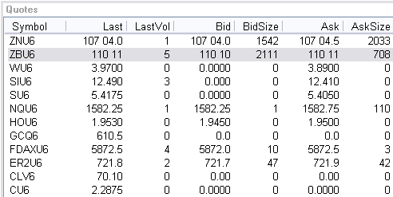
The columns can be configured to be displayed or hidden. Below is a list with all the columns available from the Quotes window.

Symbol
The contract symbol.

Last
Last price at which the contract was traded.

LastVol
The last amount of Volume that trade that specific contract.

Bid
The bid market price.

BidSize
The total amount of bids on that contract.

Ask
The offer market price.

AskSize
The total amount of offers on that contract.

High
The highest price traded of the contract during this trading session.

Low
The lowest price traded of that highlighted contract during the most current trading session.

Chg
The total amount of change from the opening of the current trading session.

Chg%
The total percentage of change from prev. day settlement.

TotalVol
The total volume traded on that specific contract through the current trading session.

Open
What the price was of the contract at the opening of the current session.

Settle
What the contract price was at the end of the most recent close.

Updated
The most recent time at which the contract’s price, bid/ask, volume etc was updated.

Base Contract
The symbol of the contract that is being traded without the year or month attached. e.g: The ESU6’s base contract is ES.

Expires
The date the contract will no longer be available to be traded.

Description
The name of the contract. e.g: 2. The ES has a description of E-Mini S&P.

Currency
The currency that the contract is traded in. e.g: 2. ES E-Mini S&P trades in USD and DAX DAX trades in EUR.

Exchange
The exchange that the selected contract is traded on.

Group
The group that the selected contracts falls under e.g. ES is a contract under the Indices Group .

Type
Whether the contract is traded electronically (E) or pit (P).

Start Time
What time the contract opens in relation to the exchange’s time zone. E.g. CME is Chicago Mercantile Exchange which is located in Chicago, IL on Central Standard Time (CST).

Stop Time
The time the contract closes in relation to the exchange’s time zone.

Tick Size
What the increment amount is per tick. The ES has a Tick Size of .25. e.g. ES has gone from 1309.50 to 1310 therefore it has increased by 2 ticks .

Per Point
The total amount of amount effected per point. The ES has a Per Point value of 50. This mean that if the market moved up one point from 1309 to 1310 someone who was Long would make $50 on a 1 lot. To find out the per tick value, multiple the Per Point value by the Tick Size. 50 x .25 = 12.50 per tick for the ES.

Charts

Charts - Open
a. Left-click on VIEW in the Toolbar Scroll down to CHARTS one up from the bottom
1. Click on NEW and Market Selection will prompt you
  - Enter the Market you want and click ok
2. Click on anything below the line i.e. Chart – 15 min (ESU6)
  - This is a chart that you have either opened during this current session or a chart that you have save

b. Right Click on the contract you want in the QUOTES box
a. Scroll down to CHARTS one up from the bottom and the chart will appear
c. Launch a DOM
1. In the top toolbar below the title bar will be a set of icons
2. The eight icon from the left looks like a bar chart
3. Put you mouse on it, so it is highlighted and left-click
4. The chart will appear for that DOM

Add Indicator

Add Indicator
Customize or select from a variety of indicators and profiles.
- Click on ADD INDICATORS in the top left corner of the chart
- Add indicators via RIGHT_CLICK shortcut. Right-Click any where on the graph and have a menu bow pop up and select ADD INDICATORS.
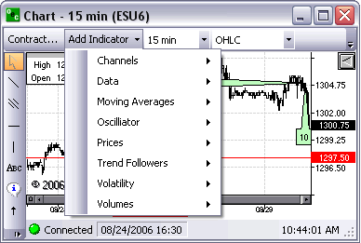

Volatility
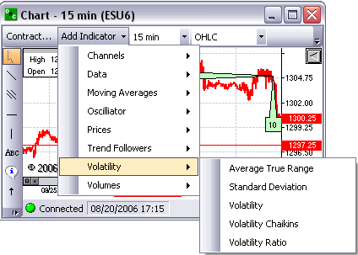

Average True Range (ATR)
- Appears below Contract chart
- Measures commitment comparing the range between High, Low and Close prices

Standard Deviation (StdDev)
- Appears below Contract chart
- Difference between values (Closing Price) and average.

Volatility (Volatility)
- Appears below Contract chart

Volatility Chaikins (CHV)
- Appears below Contract chart
- Difference between high and low prices, indicates the top and bottom of the market

Volatility Ratio (VR)
- Appears below Contract chart

Channels
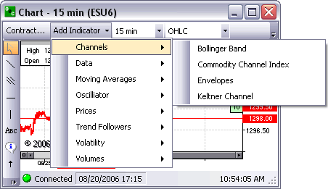

Bollinger Band
- Will put a Bollinger Band on the chart directly
- This indicator can be used to measure the relative highness or lowness of price

Commodity Channel Index
- Will put a Chart below the existing Contract chart
- Compares Prices with its moving average

Envelope
- Will apply a envelop directly on the contract chart
- Plots above and below the moving average at a specified percentage

Keltner Channel
- Will apply 3 lines to the Contract chart
- This indicator shows a central moving average line plus channel lines at a distance above and below

Data
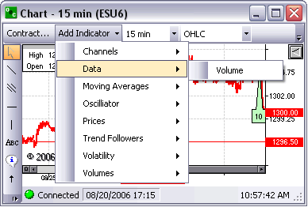

Volume
- Will put a volume chart below the contract chart
- Shows the amount of trades at a specific time of the day

Moving Averages
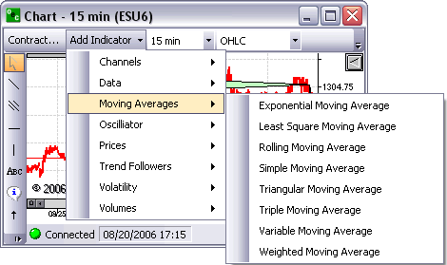

Exponential M.A. (EMA)
- Will apply a line direct to Contract Chart
- EMA is an average of data calculated over a period of time where the most recent days have more weight

Least Square M.A. (LSMA)
- Will apply a line direct to the Contract chart

Rolling M.A. (RMA)
- Will apply line direct to Contract chart

Simple M.A. (SMA)
- Will apply line direct to Contract chart
- The average of data calculated over a period of time

Triangular M.A. (TMA)
- Direct line onto Contract chart
- Average calculated over a period of time where the middle portion of the data has more weight

Triple M.A.
- Applies 3 lines on Contract chart, the Slow, the Fast and the Median

Variable M.A.
- Will apply line direct to Contract chart

Weighted M.A.
- Direct onto the Contract chart
- An Average where the greater weights are attached to the most recent data, it is calculated from the sum of the day

Oscillator
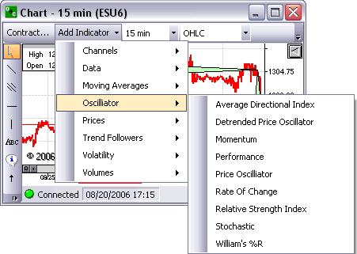

Average Directional Index
- Will appear below the Contract chart
- Will have three lines, ADX, -DI, +DI

Detrended Price Oscillator
- Will appear below Contract chart
- The Detrended Price Oscillator is used to "remove" the trend from the price. Comparing Closing or any other price with it's moving average

Momentum
- Will appear below the Contract chart

Performance
- Will appear under the Contract chart
- Compares the current Close (or any other price) with the first Close value. Shows how much the Close price was changed from the beginning

Price Oscillator
- Will display below Contract chart
- Rate of Change
- Appears below Contract chart

Relative Strength Index
- Appears below Contract chart
- Compares upward movement of the Close price with the downward movement resulting in a value which ranges from 0 and 100

Stochastic (%K, %D)
- Appears below Contract chart
- Indicator helps to find trend reversal searching for a period when close prices is close to low price in up trending market or close prices is close to high price in down trending market

William’s %R (%R)
- Places the charting below the Contract chart
- This indicator is used to measure overbought and oversold levels

Prices
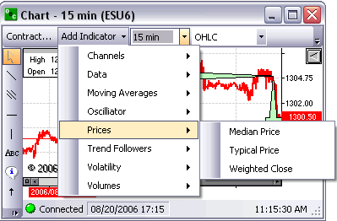

Median Price (Median)
- Places a line directly on the Contract chart
- Mid-point value of daily prices

Typical Price (Typical)
- Appears directly on the Contract chart
- The average value of the daily prices

Weighted Close (Weighted)
- Appears direct to the Contract chart
- Average value of daily prices, only difference is that the closing price has extra weight as the most important price

Trend Followers
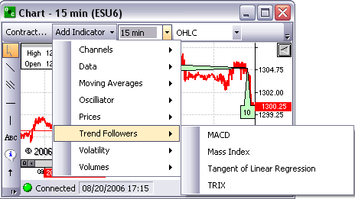

MACD (MACD, Histogram, Signal)
- Appears below Contract chart
- Compares two moving averages of prices. Is used with its 9 day Exponential Moving average as signal

Mass Index (MI)
- Below the Contract chart
- Developed to predict trend reversal by comparing difference and range between high and low prices

Tangent of Linear Regression (Tangent)
- Appears below Contract chart

TRIX (TRIX)
- Below Contract chart
- Based on triple moving average of Closing Price and its purpose is to eliminate shorter cycles

Volumes
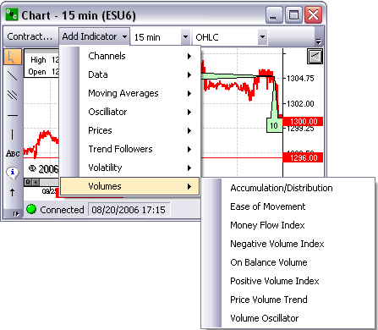

Accumulation/Distribution (A/D)
- Appears below Contract chart
- Estimates the strength of price movement with the relationship between volume and prices

Ease of Movement (EoM)
- Appears below Contract chart
- Uses volume to estimate how strong the price trend is

Money Flow Index (MFI)
- Appears below Contract chart
- Compares upward changes and downward changes of the volume weighted typical prices

Negative Volume Index (NVI)
- Appears below Contract chart
- Should be used with PVI
- Changes only if the volume decreases from the previous day

On Balance Volume (OBV)
- Appears below Contract chart
- Measures positive and negative volume flows.
- Volume is added if the closing price moves up and subtracted if the closing price moves down

Positive Volume Index (PVI)
- Appears below Contract chart
- Should be used with NVI
- Changes only if the volume decreases from the previous day

Price Volume Trend (PVT)
- Appears below Contract chart
- Cumulative volume total
- Calculated by using the relative changes of the Close price

Volume Oscillator (VO)
- Appears below Contract chart
- Tries to identify any trends in volume, comparing two moving averages; one with a short period and the second with a longer period

Period
This function allows you to set the time period for each unit (e.g. bar, candlestick, etc.) of your chart. The minimum time increment is 1 minute, and the platform can be configured to display periods of length up to one day.
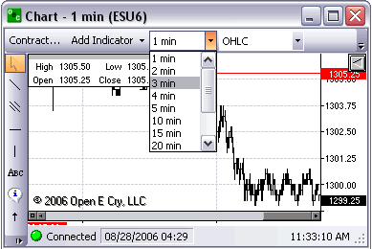

Profile
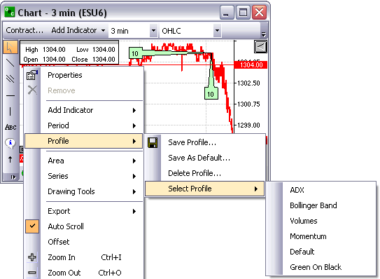

Save Profile
This allows you to save the currently selected chart with all of its settings for future use. Upon selection, this feature presents you with the opportunity to use a default chart name or create your own chart title for increased customization and personalization.

Save as Default
This allows you to not only save the currently selected chart but also to set it to your default chart upon the launching of the platform. This function is recommended for what each trader would consider being the chart from which he/she obtains the most utility.

Delete Profile
This allows you to remove a previously saved profile.

Select Profile

ADX (Average Directional Index)
This indicator evaluates the strength of the current market trend. The resulting figure is one that indicates relative strength, with further implication upon the trading style that will prove most effective in a given market. The oscillator fluctuates from 0 to 100; readings above 40 indicate a strong trend, while readings below 20 indicate one of relative weakness.

Bollinger Band
These are indicators placed at standard deviation levels away from a simple moving average. The resultant standard deviation derived from the applied formula indicates the relative volatility of the market.

Volumes
This indicator simply displays different levels of volume in a given market. A volume oscillator is intended to compare moving averages of varying time periods to compare volumes.

Momentum
The momentum profile provides the trader with a simple moving average on the chart, and, in addition, charts indicating the momentum and RSI of the market at its current state.

Default
This function returns the trader to the chart profile that he/she has saved as the contract's default profile.
vi. Green on Black: This chart is differentiated largely by its aesthetic divergence from other charts; what was once a chart of black lines against a white background is now one of green lines against a black background.

Area
Allows you the ability to see properties of series, removes series, Freeze Limits or Auto Limits
NOTE: the Contract chart will be the default chart unless you right-click on the Line or chart you want. You will know the Chart has been selected because it will have points highlighted along the line itself.
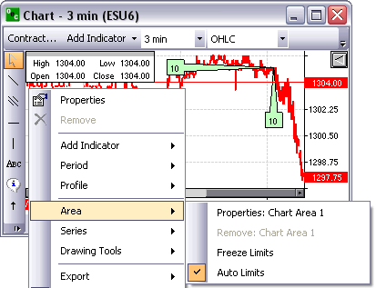

Properties: Chart Area X
Will open the Properties box on the right side of the Chart. With this you can change around and customize appearance. (SEE SELECT PROFILE > 3. PROPERTIES BOX)

Remove: Chart Area X
Will remove the selected chart from all chart area.

Freeze Limits
Freeze limit will capture the high and low prices of the currently viewed chart window. Once the prices have been captured the viewable window will not change, therefore not allowing the chart to be viewed above or below the high or low price which was frozen.

Auto Limits
Auto limit allows the viewable chart to adjust to the necessary prices accordingly. The high and the low of a specific contract will adjust its scale depending on how high or low the market price diverges from the initial median price.

Series
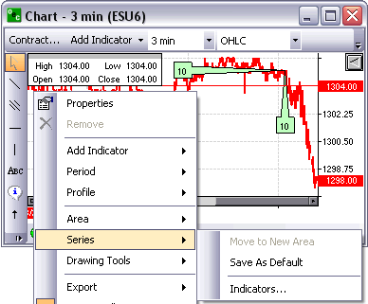

Move to New Area
Once a chart indicator has been highlighted by right-clicking on the desired chart, traders can move the chart to a new viewable window below the contract chart window. A number of indicators already start in a new chart area . Some of the moving averages for example appear directly on the contract chart, thus being able to be moved to a new chart area.

Save As Default
Saves properties as default for newly created series of the same type.

Indicators...
Shows the Indicator List Dialog. The Indicator List dialog allows traders to remove indicators or modify properties of the selected indicator.

Drawing Tools
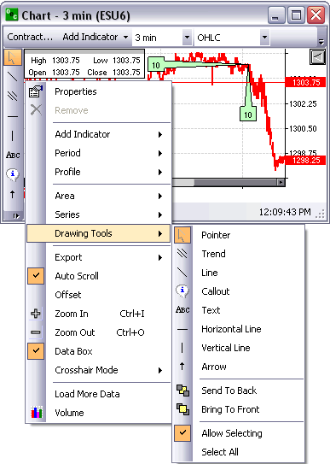

Pointer
Allows traders to highlight specific area by dragging the cursor. Once highlighted the trader can zoom in on the highlighted area.

Trend
Displays trend lines with 3 lines. The standard deviation, the variance and the average. This can be adapted by only the trends of the Chart, they are not free flowing and they are not dependent on the y axis or price.

Line
This is a free flowing chart that can be changed with not regards to either the x or y axles.

Callout
This allows traders to place call outs attached to specific high or lows at a certain time. Traders can put whatever they desire in the call outs.

Text
Text is an option where traders can put text on the chart not dependent on anything but their text within the text box.

Horizontal Line
This line can ONLY move horizontally no matter how vertical your diverge from the initial point on the line.

Vertical Line
This line can ONLy move vertically no matter how horizontal you diverge from the initial point on the line.

Arrow
Place thick highlighted arrow anywhere on the chart.

Send to Back
The options send the highlighted chart to the back of all the other charts on that same chart area.

Bring to Front
This options sends the highlighted chart to the front of all the other charts on the same chart area.

Drawing Properties
Allows you to customize the drawing properties of the previously placed drawing tools.
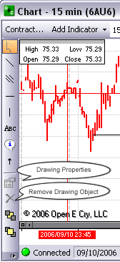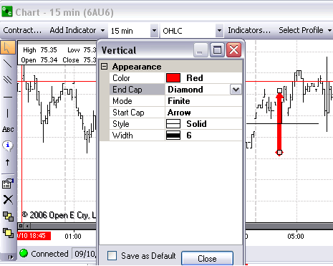
In the example above the trader drew a vertical line then while the line or object is highlighted, left-clicked 'Drawing Properties' in the left panel to view the properties window of my vertical line. I selected Color: Red, End Cap Diamond, Mode: Finite, Start Cap: Arrow, Style: Solid, Width:6.

Remove Drawing Object
The will remove the highlighted drawing from the chart area.

Allow Selecting
When 'Allow Selecting' is checked, the trader is able to highlight or select the drawn objects in the chart by performing a left-click on the desired object.

Select All
It will highlight or select all the objects drawn on the chart.

Export

Print
This function allows the trader to send the currently selected chart image to a printer of his/her choice.

Save Image
This allows the trader to save the currently selected chart as an image of specified file type on his/her computer or external drive.

Save XML
This allows the trader to save the currently selected chart as an image in XML format, which is then available for use for generation in other applications.

Copy
This allows the trader to copy the image of the currently selected chart to be able to paste into other applications.

Auto scroll
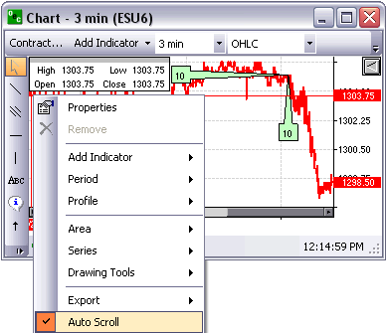
This provides a constant timeframe for the chart. In other words, as the day progresses and the chart extends out to the right, the data displayed on the chart will systematically progress toward the left in order to keep the most recent data on the right side of the chart. Auto scroll can be selected (checked) or deselected (unchecked).

Offset
This causes the display of the chart to have a relatively small blank area in between the most recent market data and the far right edge of the chart. It is largely used for the increased ease in visual distinction it provides with respect to market data. Offset can be selected (checked) or deselected (unchecked).

Zoom In (CTRL+I)
This allows the trader to decrease the amount of data viewed at one time on a chart. It allows him/her to more closely see short-term market movements.

Zoom Out (CTRL+O)
This allows the trader to increase the amount of data viewed at one time on a chart. It allows him/her to better see long-term market trends.

Data Box
This allows the trader to toggle the data box containing data such as market high, low, open, and close, normally located in the top left corner of the chart on (checked) or off (unchecked).

Crosshair Mode
This option allows the user to specify how he/she would like the crosshair feature (red cross on the chart) to be displayed.

Hidden
The crosshairs are not visible on the chart

Free
The user must click on a location on the chart to make them appear. Upon placement, they do not move unless reassigned.

Mouse
The crosshairs move unrestricted in conjunction with the user's mouse movements.

StickyClick
The vertical bar moves somewhat freely ("stickily") with the user's mouse movements, but the horizontal bar changes only upon the user's specification by mouse click.

Sticky
The crosshairs move somewhat freely ("stickily") with the user's mouse movements.

Load More Data
Load more data allows the trader to increase their viewable charts by simply clicking on the load more data. This will decrease the size of the scroll bar therefore increase the amount of data available to be viewed. The Zoom in and Zoom out are not effected by this option. Load More Data basically provides as much data as possible on the charts, allowing the trader to view multiple days if not weeks of data on one chart.

Volume
Select "Volume" in the sub menu.
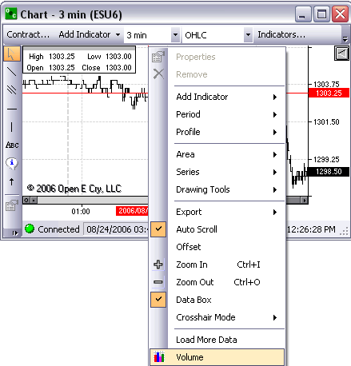

Volume view
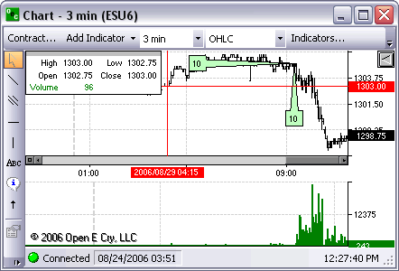

Chart Properties

Properties

Current Profile

Appearance
The chart properties are fully customizable.
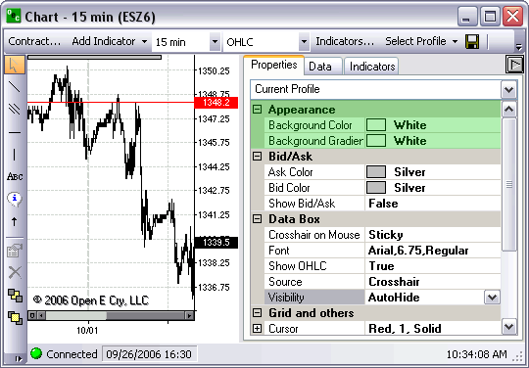

Background Color
The background can be customized by selecting any color from the drop box to the right. The color will appear on the back of the chart.

Background Gradient
This is the second color of the background. This allows the two colors to blend together. This color will be bold in the bottom right corner while the primary color will be bold in the top left corner.
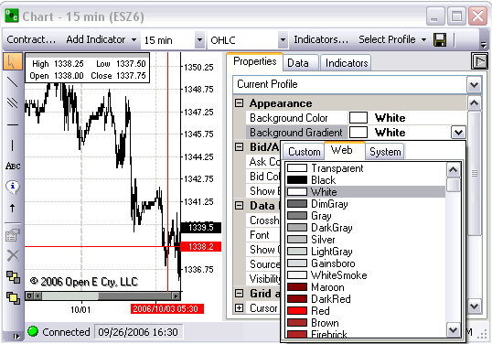

Bid/Ask
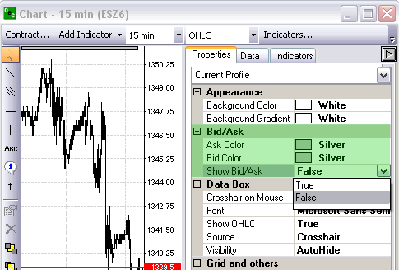

Ask Color
The color of the Ask price on the Y axis.

Bid Color
The color of the Bid price on the Y axis.
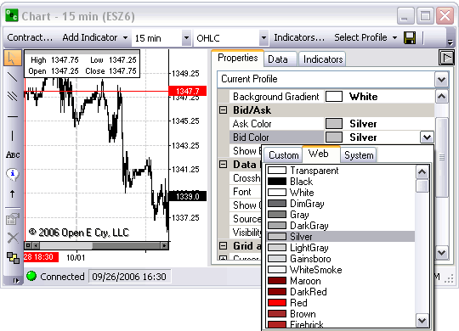

Show Bid/Ask
When ‘False’ is present the Bid/Ask price are not visible. Click on ‘False’ and change it to ‘True’ allowing the Bid/Ask to be viewed for the most current price.
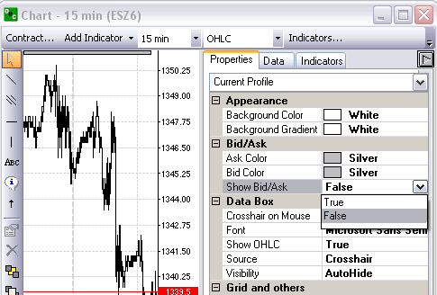

Data Box
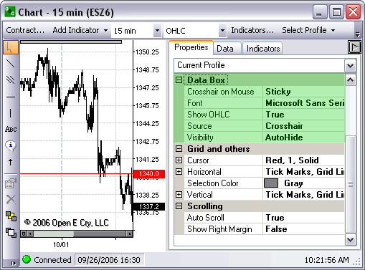

Crosshair on Mouse
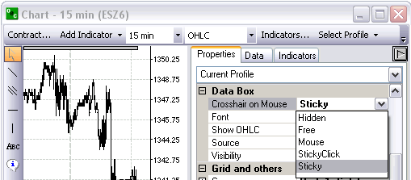

Hidden
The crosshairs are not visible on the chart

Free
The user must click on a location on the chart to make them appear. Upon placement, they do not move unless reassigned.

Mouse
The crosshairs move unrestricted in conjunction with the user's mouse movements.

StickyClick
The vertical bar moves somewhat freely ("stickily") with the user's mouse movements, but the horizontal bar changes only upon the user's specification by mouse click.

Sticky
The crosshairs move somewhat freely ("stickily") with the user's mouse movements.

Font
Customize the Font, Size and Style of the Fonts that appear on your charts and in the Data feed on the Chart; aka OHLC (Top left corner by default).
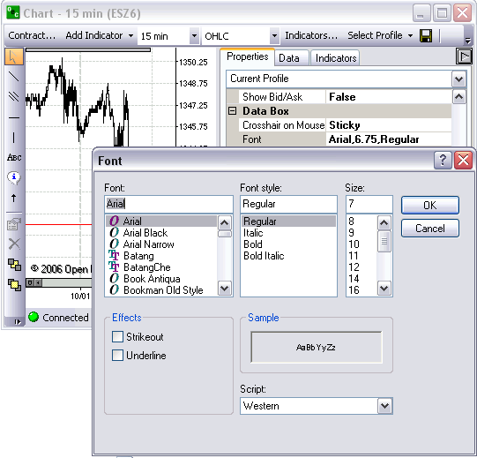

Show OHLC
The Open High Low Close is by default displayed in the top left corner. It tracks the data that your mouse is moving over.
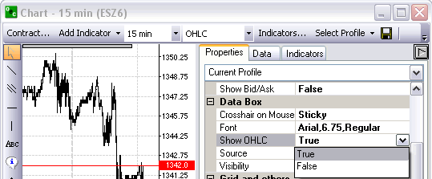

Source
Provides the type of data that will appear in the OHLC box in the top right corner.
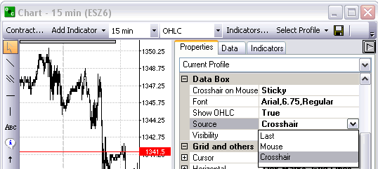

Last
The most current data presented in the OHLC.

Mouse
Presents the data from the location of your mouse on the chart.

Crosshair
Presents the strict data from exactly where the crosshairs are in relation to the contract chart.

Visibility
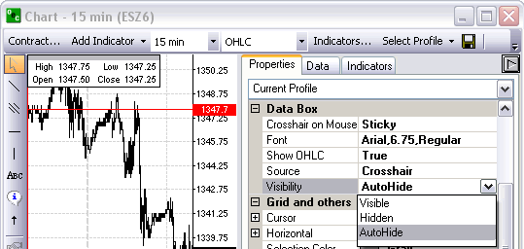

Visible
The OHLC will always be on the chart.

Hidden
The OHLC will never be on the chart.

AutoHide
The OHLC will hide when the cursor is off the chart and will appear when the cursor moves over the chart.

Grid and Others
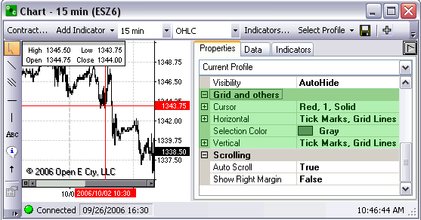

Cursor
General Information about the Crosshair.
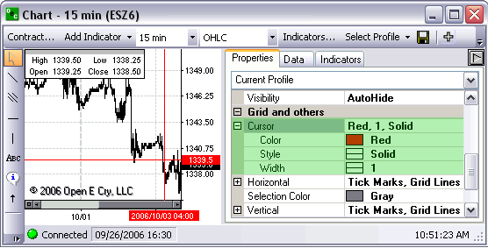

Color
Specific color of the crosshair.

Style
Specific style of the crosshair whether it be a dotted line, a dashed line, a solid line, etc.

Width
The thickness of the cursor

Horizontal
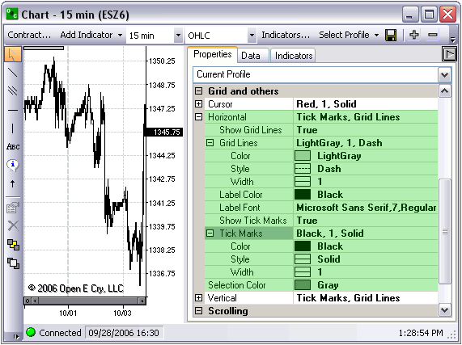

Show Grid Lines
Shows the horizontal grid lines. In order to turn the horizontal grids lines off switch ‘True’ to ‘False’.
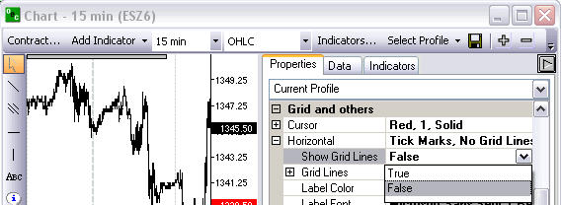\

Grid Lines
General information about the horizontal grid lines.
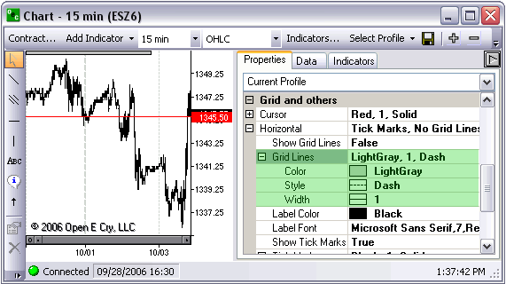

Color
Specific color of the horizontal grid lines.

Style
Specific style of the horizontal grid lines whether it be a dotted line, a dashed line, a solid line, etc.

Width
The thickness of the horizontal grid lines.

Label Color
The color of the labels on the horizontal axis (Time)

Label Font
The font of the labels on the horizontal axis

Show Tick Marks
Shows ticks from the horizontal line to the labels. Can change visibility of the horizontal ticks by changing ‘True’ to ‘False’.

Tick Marks
General information about the Tick Marks.
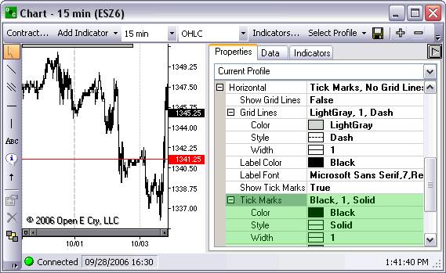

Color
Specific color of the ticks on the horizontal axis

Style
The style of the ticks on the horizontal axis

Width
The thickness of the ticks on the horizontal axis

Selection Color
The color you desired for the selected area if you were to drag you cursor from one point to another

Vertical
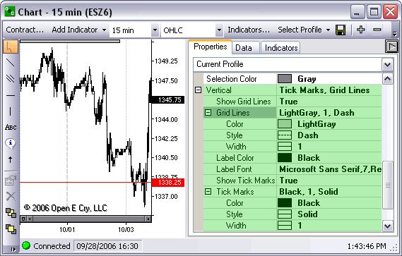

Show Grid Lines
Shows the vertical grid lines. In order to turn the vertical grids lines off switch ‘True’ to ‘False’

Grid Lines
General information about the vertical grid lines

Color
Specific color of the vertical grid lines

Style
Specific style of the vertical grid lines whether it be a dotted line, a dashed line, a solid line, etc.

Width
The thickness of the vertical grid lines

Label Color
The color of the labels on the vertical axis (Time)

Label Font
The font of the labels on the vertical axis

Show Tick Marks
Shows ticks from the vertical line to the labels. Can change visibility of the vertical ticks by changing ‘True’ to ‘False’

Tick Marks
General information about the Tick Marks

Color
Specific color of the ticks on the vertical axis

Style
The style of the ticks on the vertical axis

Width
The thickness of the ticks on the vertical axis

Scrolling
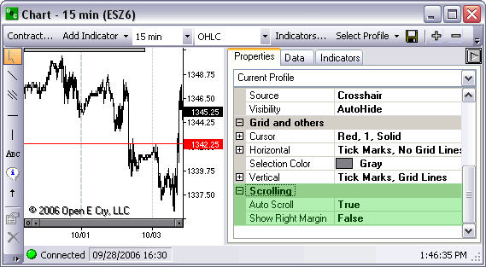

Auto Scroll
Keeps the horizontal scroll bar at the bottom always at the most current price or at the most far right price

Show Right Margin
Offsets the scroll bar so the margin between the Y axis and the most current price is viewable

Chart Area 1

Misc
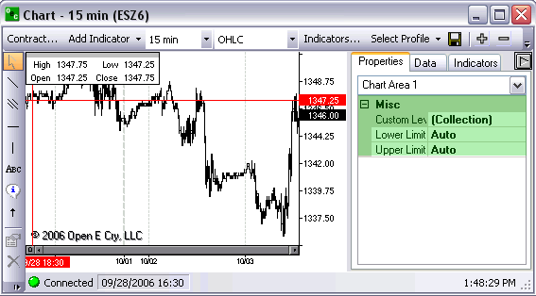

Custom Levels

Lower Limit
Allows you to set a specific price at which your viewable chart will not move below.

Upper Limit
Allows you to set a specific price at which your viewable chart will not exceed.

Contract (ei: ESZ6)

Appearance
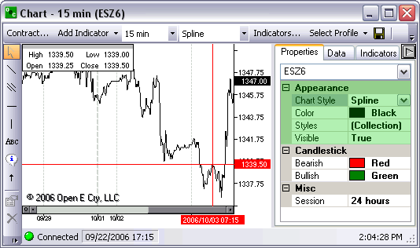

Chart Style
Select the style of the chart you wish to view whether it be OHLC, Spline, Candlestick, Area, Stepline, etc.

Color
The color of the main contract chart

Styles
The specifics of the main contract chart

Visible
Whether or not the main contract chart is viewable

Candlestick
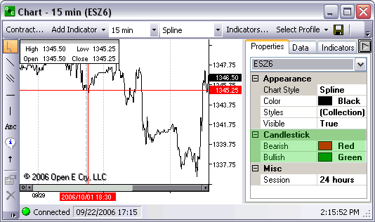

Bearish
The color of bearish candlesticks

Bullish
The color of the bullish candlesticks

Misc
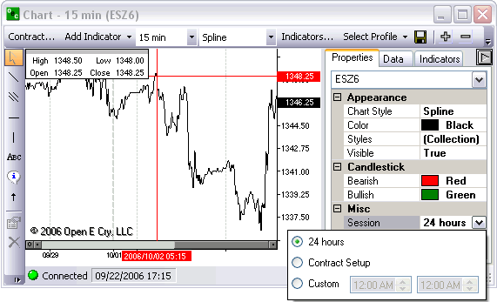

Session
The time span you wish to view the chart

24 hours
24 hours a day will be viewable

Contract Setup
The session will include only from the contract opening till the contract close

Custom
Select the time session you wish to view the contract

Additional Indicators

Appearance
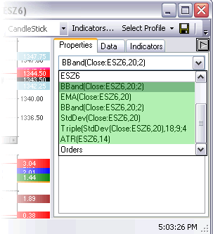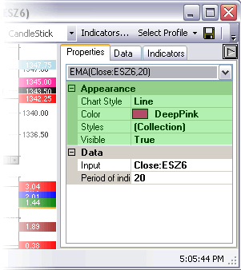

Chart Style
The style of line the indicator chart will have, whether it be line, area, point, spline, etc.

Color
The color of the indicator chart

Styles
Specifics of the indicator chart

Visible
Whether or not the indicators is viewable

Data
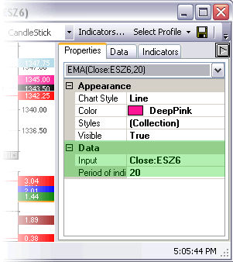

Input
Depending on the indicators, the data the indicator is having the information input from.

Period of indicator
The amount of data the indicators is viewing its information from based on the time or period indicated

Orders

Appearance

Font
Customize the Font, Size and Style of the Fonts that appear on your charts and in the Data feed on the Chart; aka OHLC (Top left corner by default).
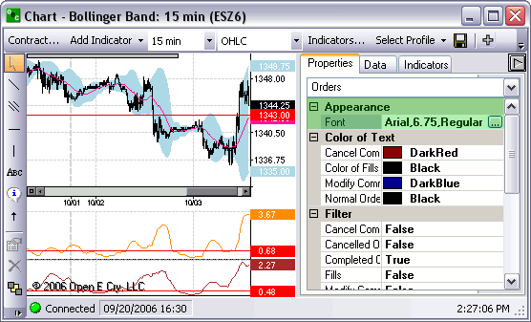

Color of Text
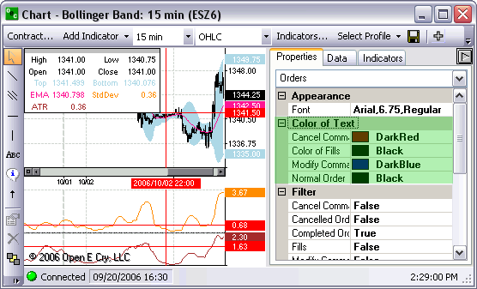

Cancel Command
The color of the text in an order indicator will appear by default Dark Red for cancel commands

Color of fills
The color of the text in an order indicator will appear by default Gray for Fills

Modify Command
The color of the text in an order indicator will appear by default Dark Blue for Modify Commands

Normal Order
The color of the text in an order indicator will appear by default Black for Normal Order

Filter
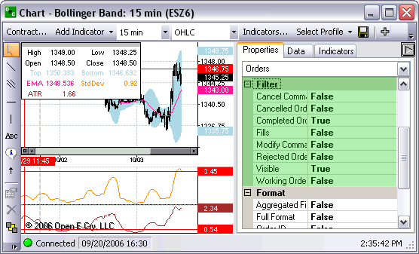

Cancel Commands
This option offers the ability to view cancel commands on your chart, by default they are off.

Cancelled Orders
This option offers the ability to view cancelled orders on your chart, by default they are off.

Completed Orders
This option offers the ability to view completed orders on your chart, by default they are on.

Fills
This option offers the ability to view fills on your chart, by default they are off.

Modify Commands
This option offers the ability to view modify commands on your chart, by default they are off.

Rejected Orders
This option offers the ability to view rejected orders on your chart, by default they are off.

Visible
This option allow traders to turn the orders on or off without manually going thru each individual filter type. If traders want to turn the viewable filters off simply change ‘True’ to ‘False’.

Working Orders
This option offers the ability to view working orders on your chart, by default they are off.

Format
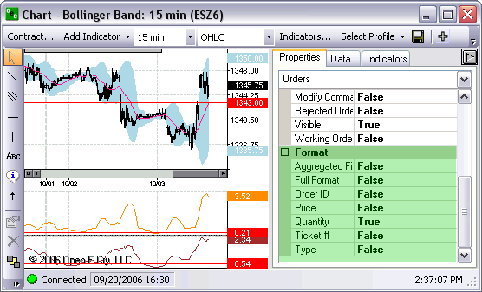

Aggregated Fills
Shows each individual quantity and the price they traded at. They are faint grey color to indicate that they are aggregated fills

Full Format
Indicates the type, the quantity, the contract and the side of how the trade was placed

Order ID

Price
Provides the price of the trade in the viewable filters

Quantity
Provides the quantity of the trade in the viewable filters

Ticket #
Provides the ticket number accompanied by the full format indicators in the viewable filters

Type
Provides the type of order that was placed in the viewable filters.

Data

Data
Information on the chart in relation to the cross-hairs on the charted contract.
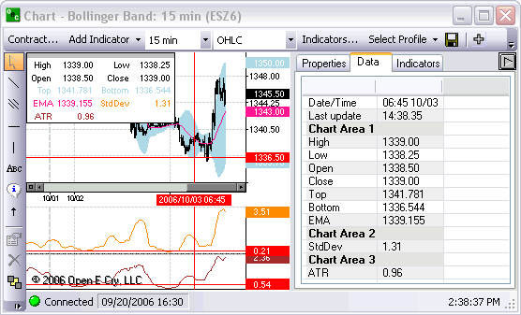

Date/Time
The time and date where the cross-hairs cross the X axis (bottom axis).

Last updated
The time the entire contract was most recently update with new data.

High, Low, Open, Close
The data is determined by the location of your cross-hairs on the chart. If the cross hairs are below the chart they will cross at the low on the Y axis. If the cross hairs are above the chart they will cross at the high on the Y axis.

Indicators

Channels

Channels
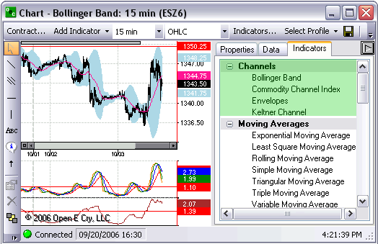

Bollinger Band
Will put a Bollinger Band on the chart directly
This indicator can be used to measure the relative highness or lowness of price.
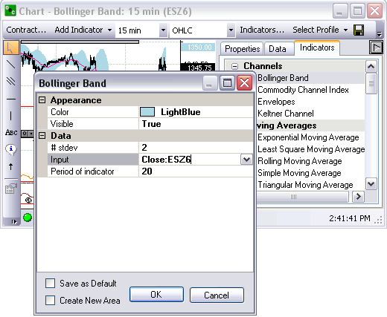

Commodity Channel Index
Will put a Chart below the existing Contract chart.
Compares Prices with its moving average.
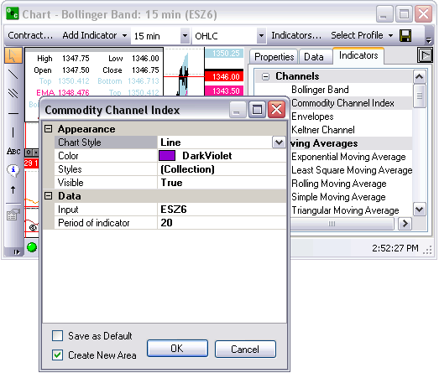

Envelope
Will apply a envelop directly on the contract chart.
Plots above and below the moving average at a specified percentage.
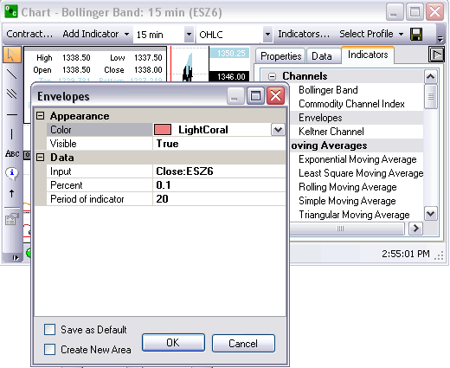

Keltner Channel.
Will apply 3 lines to the Contract chart
This indicator shows a central moving average line plus channel lines at a distance above and below.
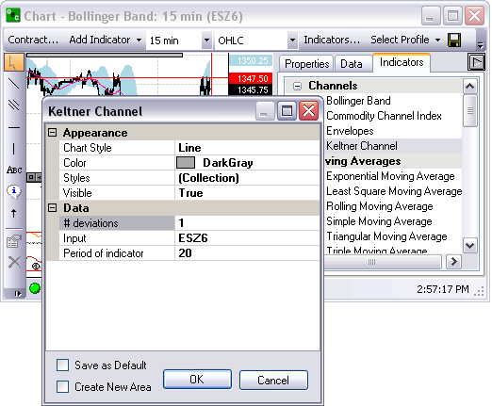

Moving Averages
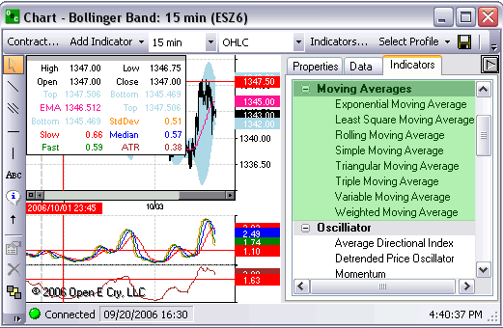

Exponential M.A. (EMA)
Will apply a line direct to Contract Chart.
EMA is an average of data calculated over a period of time where the most recent days have more weight.
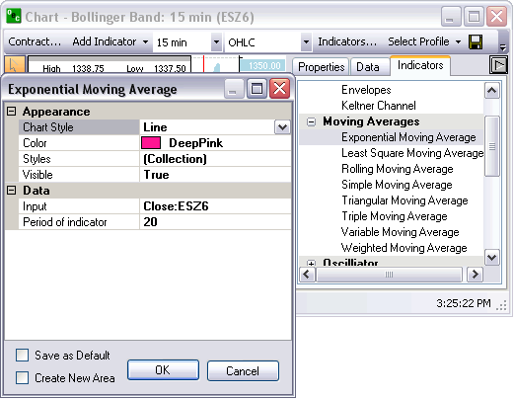

Least Square M.A. (LSMA)
Will apply a line direct to the Contract chart.
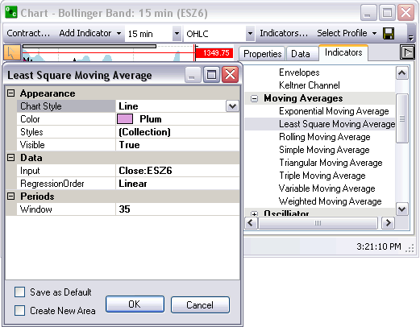

Rolling M.A. (RMA)
Will apply line direct to Contract chart.
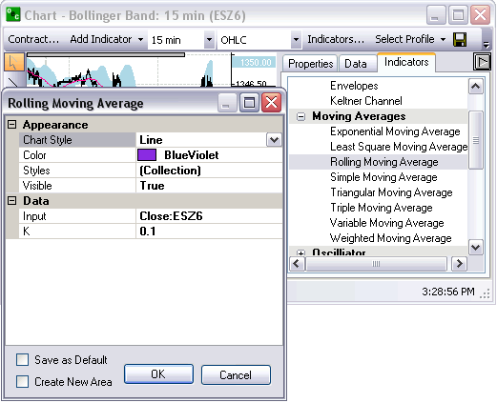

Simple M.A. (SMA)
Will apply line direct to Contract chart.
The average of data calculated over a period of time.
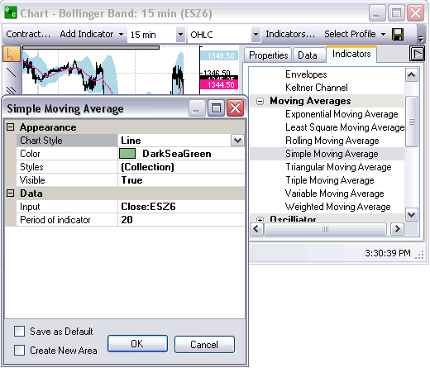

Triangular M.A. (TMA)
Direct line onto Contract chart
Average calculated over a period of time where the middle portion of the data has more weight.
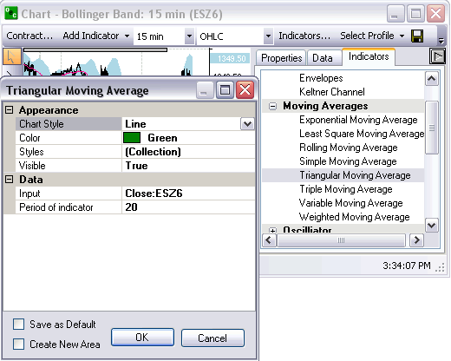

Triple M.A.
Applies 3 lines on Contract chart, the Slow, the Fast and the Median.
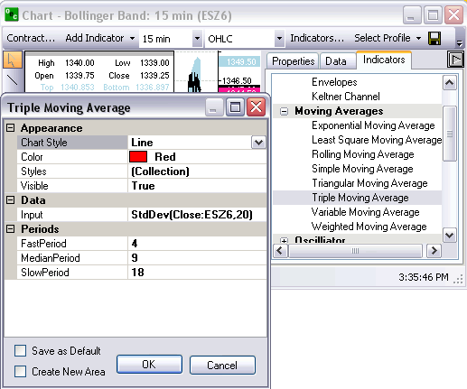

Variable M.A.
Will apply line directly to Contract chart.
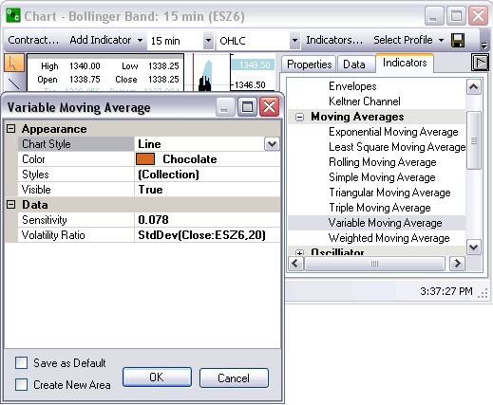

Weighted M.A.
Direct onto the Contract chart.
An Average where the greater weights are attached to the most recent data, it is calculated from the sum of the day.
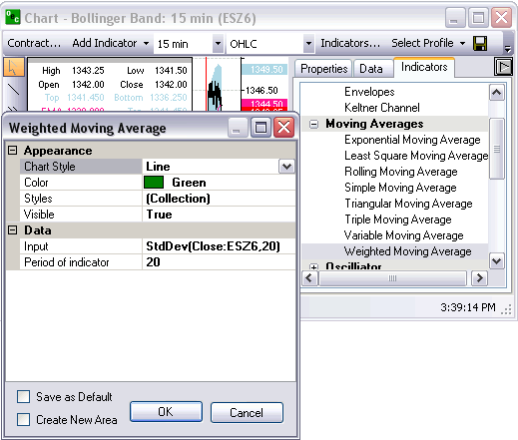

Oscillator
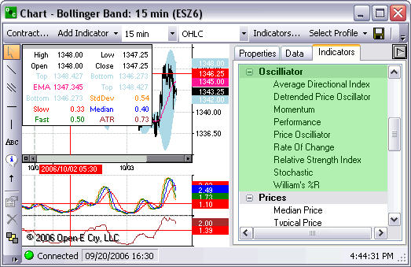

Average Directional Index
Will appear below the Contract chart.
Will have three lines, ADX, -DI, +DI.
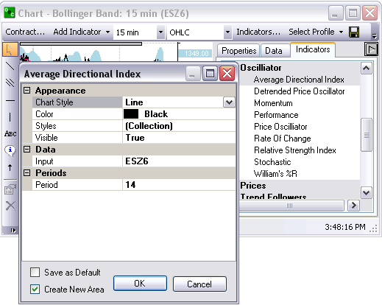

Detrended Price Oscillator
Will appear below Contract chart.
The Detrended Price Oscillator is used to "remove" the trend from the price. Comparing Closing or any other price with it's moving average.
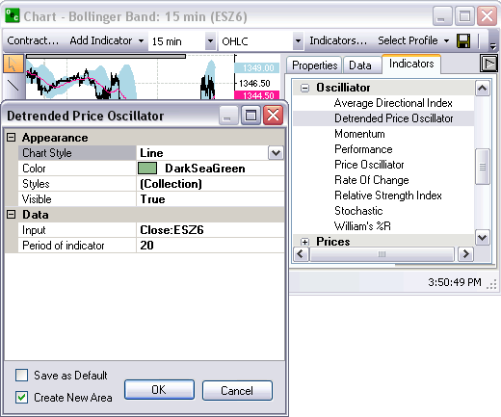

Momentum
Will appear below the Contract chart.
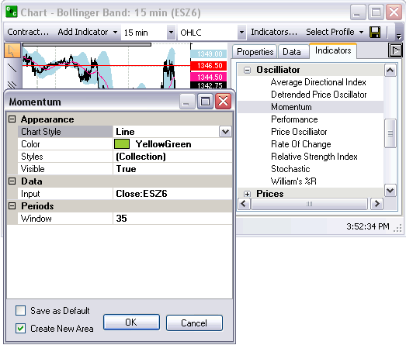

Performance
Will appear under the Contract chart.
Compares the current Close (or any other price) with the first Close value. Shows how much the Close price was changed from the beginning.
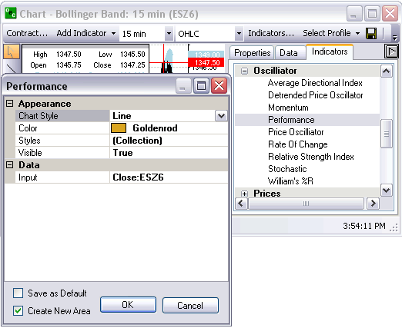

Price Oscillator
Will display below Contract chart.
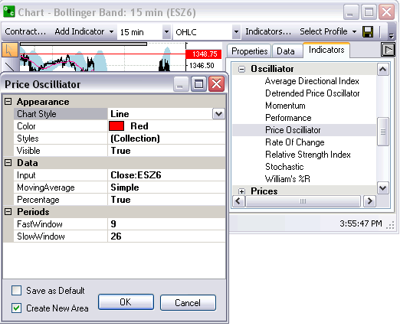

Rate of Change
Appears below Contract chart.
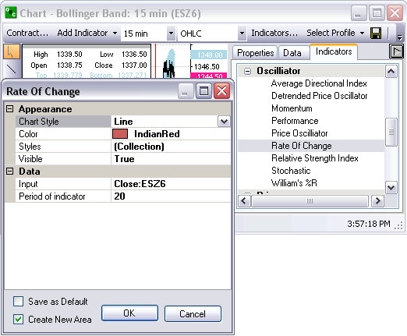

Relative Strength Index
Appears below Contract chart.
Compares upward movement of the Close price with the downward movement resulting in a value which ranges from 0 and 100.
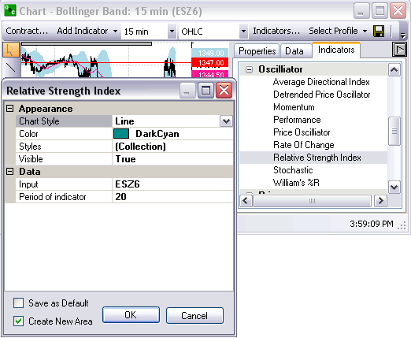

Stochastic (%K, %D)
Appears below Contract chart.
Indicator helps to find trend reversal searching for a period when close prices is close to low price in up trending market or close prices is close to high price in down trending market.
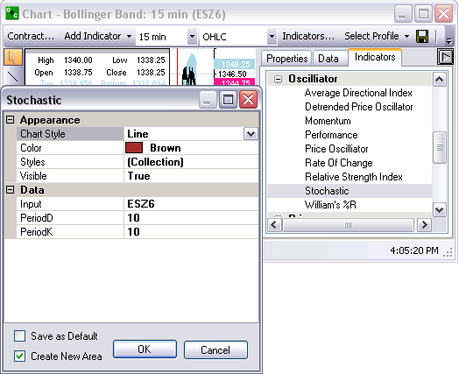

William’s %R (%R)
Places the charting below the Contract chart.
This indicator is used to measure overbought and oversold levels.
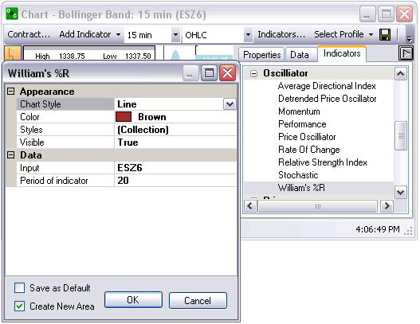

Prices
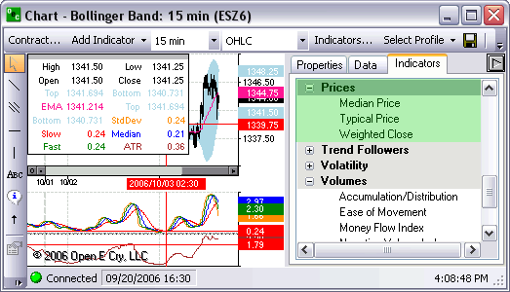

Median Price (Median)
Places a line directly on the Contract chart.
Mid-point value of daily prices.

Typical Price (Typical)
Appears directly on the Contract chart.
The average value of the daily prices.

Weighted Close (Weighted)
Appears direct to the Contract chart.
Average value of daily prices, only difference is that the closing price has extra weight as the most important price.

Trend Followers
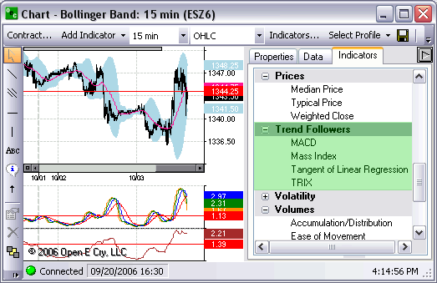

MACD (MACD, Histogram, Signal)
Appears below Contract chart.
Compares two moving averages of prices. Is used with its 9 day Exponential Moving average as signal.

Mass Index (MI)
Below the Contract chart.
developed to predict trend reversal by comparing difference and range between high and low prices.

Tangent of Linear Regression (Tangent)
Appears below Contract chart.

TRIX (TRIX)
Below Contract chart.
Based on triple moving average of Closing Price and its purpose is to eliminate shorter cycles.

Volatility
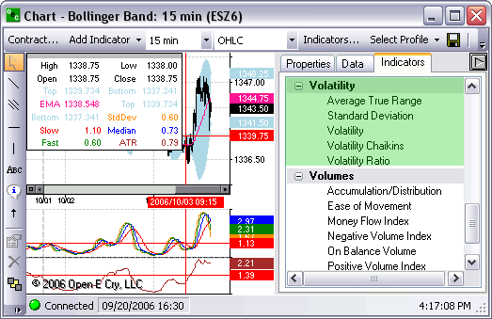

Average True Range (ATR)
Appears below Contract chart.
Measures commitment comparing the range between High, Low and Close prices .

Standard Deviation (StdDev)
Appears below Contract chart.
Difference between values (Closing Price) and average.

Volatility (Volatility)
Appears below Contract chart.

Volatility Chaikins (CHV)
Appears below Contract chart.
Difference between high and low prices, indicates the top and bottom of the market.

Volatility Ratio (VR)
Appears below Contract chart.

Volumes
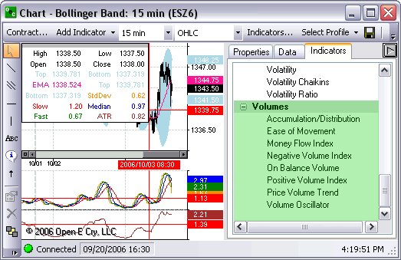

Accumulation/Distribution (A/D)
Appears below Contract chart.
Estimates the strength of price movement with the relationship between volume and prices.

Ease of Movement (EoM)
Appears below Contract chart.
Uses volume to estimate how strong the price trend is.

Money Flow Index (MFI)
Appears below Contract chart.
Compares upward changes and downward changes of the volume weighted typical prices.

Negative Volume Index (NVI)
Appears below Contract chart.
Should be used with PVI.
Changes only if the volume decreases from the previous day.

On Balance Volume (OBV)
Appears below Contract chart.
Measures positive and negative volume flows.
Volume is added if the closing price moves up and subtracted if the closing price moves down.

Positive Volume Index (PVI)
Appears below Contract chart.
Should be used with NVI.
Changes only if the volume decreases from the previous day.

Price Volume Trend (PVT)
Appears below Contract chart.
Cumulative volume total.
Calculated by using the relative changes of the Close price.

Volume Oscillator (VO)
Appears below Contract chart.
Tries to identify any trends in volume, comparing two moving averages; one with a short period and the second with a longer period.

Communications

Research
This window displays important messages that consist of major market issues sent from the brokers to the entire OEC population. It also displays Risk messages such as available credit, etc.
Each time a research appears it will be accompanied by a topic first then a message. The broker can make it as specific as possible for quick reference by using the seven templates. The topics are Indices, Currencies, Energies, Grains, Metals, News, and General.
To access Research:
- From Communications menu options, click on the "Research Window"; if the option has a check next to it then it’s available to view; if it does not have a check then it isn’t available to view.
- From View menu, click on Research in order to make it highlighted.

Chat
Allows one customer to directly ask questions, get quotes, place orders, etc with a broker. The broker answers the questions/comments via the CHAT box.
We highly recommend most questions be transmitted via the CHAT box. It is the most streamline method of communication.
In order to initiate chat with a BROKER, select their name (i.e. OECBroker9) and type your message in the open row at the bottom. Once you have entered your text you will be offered the SUBMIT button. Click on the SUBMIT button and the broker you selected will receive your message. The drop box is there for your reference so you can repeat your self with previous comments or say the same thing to a different broker by just clicking into the drop box and selected the previously written text.
To access Chat:
- From Communications menu options, click on the CHAT option. If it is already checked it will uncheck the CHAT option and it’ll be unavailable to chat.
- From View menu, click on Chat in order to make it highlighted.

Reports

Access Reports
Each report can be filtered by one account or all and date ranges. They can be viewed in PDF or Excel format. Access any one of the following reports.

Daily Fills
Shows the daily fills for the designated dates indicated above.

Daily Activity
Daily Activity is the number and contracts that you traded on the dates indicated above.

Working Orders
Working orders are the orders that are working or have been working from the date increment from above.

Rejected Orders
This report indicates all the rejected orders within the dates entered above.

Order Statistics
The number of orders placed, orders cancelled, orders filled, open orders, the number bought and the number sold for the date above and within the contracts that were traded.

Order Ticket Statistics
The method the orders were placed weather they be AOE, Turbo, Rapid or DOM and the order statistics for each order method.

P/L Summary
The Profit and Loss for each trade placed and the order statistics, for the date(s) provided above.

Chat History
The chat history is recorded for quick reference and for security reason. This allows traders and brokers to view previous conversations between trader and broker.

News History
The Research comments that have been presented by the Brokers to the entire OEC population. These messages are important details from the broker involving major Futures issues.

Order Details
Provides a detailed description of each trade made and the necessary identifications for each detail within the order placed.

Daily Positions
Daily Positions represents the positions for the account above between the dates indicated.

Trade Log
Provides a detailed description of the trades placed. The trade log provides the time, side, the contract, the price and the amount at which each trade was place.

Open Orders
Provides the list of open orders that exist with in that account.

Setup

Shortcut Manager
Allows you to customize the hotkeys for a vast amount of E-Futures International Trading options.

Quick Start
Allows you to view the quick start menu which has a direct link to the Quick Start Guide, Depth user’s guide and all the contact info for customer service and support.

Toolbox

Contract List
Display the Open E Cry's Contract List web page with your default browser.
URL: http://www.openecry.com/platforms/available.cfm

Contract Margins
Display the Open E Cry's Contract Margins web page with your default browser.
URL: http://www.openecry.com/traderstoolbox/margins.cfm

Contract Specs
Display the Open E Cry's Contract Specifications web page with your default browser.
URL: http://www.openecry.com/traderstoolbox/contract.cfm

Glossary
Display the Open E Cry's Glossary web page with your default browser.
URL: http://www.openecry.com/traderstoolbox/glossary.cfm

Help

Contact Us
Display the Open E Cry's Contact web page with your default browser where you can direct questions/comments to our staff.
URL: http://www.openecry.com/company/contact.cfm

About
Displays the current information of the platform that the trader is currently running.

Open Live Account

Open Live Account (DEMO ONLY)

Demo Only
Display the Open E Cry's Online Application with Electronic Signature web page with your default browser.
URL: https://www.openecry.com/openaccount/applyonline.cfm

Advanced Features

Advanced Orders

Order Flags

Good Till Cancelled (GTC)
Order remains on the books until cancelled and can be filled at an undesirable time if forgotten.

Fill or Kill (FOK)
LMT orders which, if not filled immediately, are cancelled.

Immediate or Cancel (IOC)
LMT orders which, if not filled immediately, are cancelled.

OCO Orders
OCO (One cancels other) is a pair of orders sent together.
Currently only Limit and Stop orders of one side (buy limit/buy stop or sell limit/sell stop) are supported.
- To send OCO orders, user needs to check OCO toolbar button, and then send two orders in usual way. Another way to enter a single pair of OCO orders, user could hold SHIFT key while clicking.
- After clicking first order, the price would be marked with different color, until second order is entered. To cancel OCO order entry after first order is entered, user should uncheck OCO toolbar button (or release SHIFT key).
Working OCO orders are displayed in blue color by default.

Stop Limit/Trailing Stop

Stop Limit (STP LMT)
- Orders are used like STP orders, but execution is restricted to the limit price or better. They do not become MKT orders once the STP price has been reached
- Buy STP LMT is activated when the commodity is bid or traded at or above the STP level, the order will not be filled unless the price remains at or drops below the limit level
- Sell STP LMT is activated when the commodity is offered or traded at or below the STP level, the order will not be filled unless the price remains at or rises above the limit level
- No order can be guaranteed an execution

Trailing Stop (Tr STP)
A complex stop-loss order in which the stop loss price is set at some fixed percentage below the market price. If the market price rises, the stop loss price rises proportionately, but if the stock price falls, the stop loss price doesn't change. This technique allows an investor to set a limit on the maximum possible loss without setting a limit on the maximum possible gain, and without requiring paying attention to the investment on an ongoing basis
Trailing Stop (Stop Limit) order is a Stop order which “follows” the market price. By checking “Trailing Stop” checkbox all stop/stop limit orders would be sent as Trailing Stop/Stop Limit orders.
The Control key negates this checkbox settings, so right clicking with “CTRL” key pressed sends trailing stop order, if this checkbox isn’t checked, or sends normal stop order if the checkbox is checked.
The “Factor” value controls the minimum market price change that would case order to “trail”. Its minimum value is one tick of selected contract.
Trailing Stop order could be sent as an individual order, or as a linked (bracket) order.
Trailing Stop order couldn’t be part of OCO orders pair.
Working Trailing Stop orders displayed in green color by default.

How to execute
- Check the Box next to STOP LIMIT and/or TRAILING STOP.
- The Cursor will indicate when a trailing stop/stop limit order is available
- Right click above the market to initiate the trade

Bracket Options
Inactive Linked orders are displayed with + sign (see picture), and could be modified or cancelled separately from master order, but master order cancellation would cancel inactive Linked orders.
Brackets are group of orders – master and 1 or 2 linked. Linked orders are activated when master order is filled. They are mostly used to create a “bracket” around open position, so they are called brackets. However, user can enable only one part of bracket (Stop or Limit)
When Bracket checkbox of corresponding price is checked, order would be sent as bracketed order. However, if order is closing or reducing existing open position, it would not be sent as bracket.
Factors are price difference between bracket orders and master order
When user is moving mouse pointer over the order entry area, places for bracket orders are indicated on the opposing side in orange, and prices also highlighted (see picture).
If market bracket order is sent, bracket prices are determined against current bid/ask price.
If both Limit and Stop checkbox are checked, linked orders will be sent as OCO order pair.
If only Stop is checked, it is possible to send linked Trailing Stop order (by checking Trailing Stop checkbox also).
Inactive Linked orders are displayed with + sign (see picture), and could be modified or cancelled separately from master order, but master order cancellation would cancel inactive Linked orders.

Buy Bracket
Click on the Buy Bracket Box to activate the option of placing a BUY Bracket
If the Box is filled in with a box then only one of the two legs are checked

Sell Limit
If sell LMT is checked then the bracket will have the Sell LMT side attached being placed above the market on the opposite side of the Buy Bracket
This factor indicates how far from the BUY order the Sell LMT will be

Sell Stop
If sell STP is checked the bracket will have the Sell STP leg attached
This indicates where the sell STP will be placed from the BUY bracket

Sell Bracket
Click on the Sell Bracket Box to activate the option of placing a SELL Bracket
If the Box is filled in with a box then only one of the two legs are checked

Buy Stop
If buy STP is checked then the bracket will have the buy STP leg attached being placed above the MKT on the opposite side of the Sell Bracket
This factor indicates how far from the Sell order the Buy STP will be bracketed

Buy Limit
If buy LMT is checked the bracket will have the Buy LMT leg attached be placed beloved the MKT on the opposite side of the initial trade
This indicates where the sell STP will be placed from the BUY bracket

Glossary
#
2DNR: Two-day range (high-low) that is narrower than any two day range in the preceding 20 days.
3Day: The 3-day market pattern as described in “The Taylor Trading Technique by George Douglass Taylor. B=Buy, S=Sell, SS=Short Sale.
3DNR: Three-day range (high-low) that is narrower than any three day range in the preceding 20 days.
A
Account balance: The amount of money or debt in an account.
Account Number: (1) A series of characters (alpha and/or numeric) used to identify a customer account or relationship. (2) The remitting financial institution's account serviced by the receiving bank. (3) The identification assigned by a financial institution often called the account number.
Account position: The balance and current holdings of an account.
Ask: An indication by a trader or a dealer of a willingness to sell a security, a futures, or other financial instrument. The price at which an investor can buy. Syn. offer. See also bid; quotation.
Asked: The price that someone is willing to accept for a security, futures or other financial instrument. The ask portion of a quote is the lowest price anyone is willing to accept at that time.
Asked Price: The price at which sellers offer securities, futures or other financial instrument to buyers. Also called offer price.
At-the-money: An option with a strike price equal to the current price of the instrument, such as a stock, upon which the option was granted.
At-the-opening order: An order that specifies it is to be executed at the opening of the market or of trading or else it is to be canceled. The order does not have to be executed at the opening price, but within the opening range of prices.
At or better: (1) In a buy order for securities, futures or other financial instruments it is purchasing at the specified price or under it (2) For a sell order, it is selling at the specified price or above it. See limit order
B
Bear Market (bear/bearish): A market in which prices are declining. A trader who believes prices will move lower is called a “bear.” A period of generally failing prices and pessimistic attitudes.
Beta: A measure of an investment's volatility. The lower the beta, the less risky the investment.
Bid: An indication of a trader of a willingness to buy a security. The price at which an investor can sell.
Bid-offer spread: The difference between the bid price and the offer price.
Break-even point: (1) The point at which gains equal losses. (2) The price a market must reach for an option buyer to avoid a loss if he exercises. For a call, it is the strike price plus the premium paid. For a put, it is the strike price minus the premium paid.
Broker: An individual or firm that charges a fee or commission for executing buy and sell orders placed by another individual or firm, floor broker in commodities futures trading, a person who actually executes orders on the trading floor of an exchange; an account executive (associated person) as the person who deals with customers and their orders in commission house offices.
Buy Limit order: An order to a broker to buy a specified quantity of a security at or below a specified price (called the limit price).
Buy on close: Buying securities, futures or other financial instruments at the end of a trading session at a price within the closing range.
Buy on opening: Buying securities, futures or other financial instruments at the beginning of a trading session at a price within the opening range.
Buy Stop Order: An order to buy a market that is entered at a price above the current offering price and that is triggered when the market price touches or goes through the buy stop price.
Buying Hedge (or Long Hedge): Buying futures contracts (or other financial instruments) to protect against possible increased cost of inputs slated for futures uses. See Hedging.
C
Closing balance: The balance of entries posted to the account at the close of the statement period.
Closing price: The price at which transactions are made just before the close on a given day. A number of transactions are often made at this time and they will be included over a range of prices. See also closing range.
Commission: (1) A fee charged by a broker to a customer for performance of a specific duty, such as the buying or selling of futures contracts. Banks charge commissions for issuing letters of credit, accepting drafts drawn under letters of credit, entering foreign exchange transactions for their customers, custodial services, acting as fiscal agent, etc. Fees are paid by banks to others for various services and include fees to foreign exchange brokers for arranging foreign exchange transactions. A commission must be fair and reasonable, considering all the relevant factors of the transaction. (2) Sometimes used to refer to the Commodity Futures Trading Commission (CFTC).
Commodity: An entity of trade or commerce, services, or rights in which contracts for future delivery may be traded. Some of the contracts currently traded are wheat, corn, cotton, livestock, copper, gold, silver, oil, propane, plywood, currencies, Treasury Bills, Treasury Bonds, and Stock Indexes.
Contract Month: The month in which deliveries to be made in accordance with a futures contract.
D
Day Trade: The purchase and sale of a futures or an options contract in the same day, thus ending the day with no established position in the market or being flat.
Delivery Month: A calendar month during which a futures or options contract matures and becomes deliverable.
F
FOK (Fill or Kill): FOK (Fill or Kill) When an order is given to a broker that must immediately be filled in its entirety or, if this is not possible, totally canceled.
G
GTC (Good until cancelled): GTC (Good until cancelled) orders are generally held on file and considered to be active unless cancelled by you. Upon expiration of the contract, the GTC order will be automatically cancelled.
I
Initial Margin: The minimum value on deposit in your account to establish a new futures or options position, or to add to an existing position. Initial margin amount levels differ by contract. Brokerage firms set the level of Initial Margin required, and it may change at any time at their discretion. Increases or decreases in Initial Margin levels reflect anticipated or actual changes in market volatility. Also called "Initial Performance Bond." (See also Margin)
Intrinsic Value: The absolute value of the in the money amount; that is, the amount that would be realized if an in the money option were exercised.
IOC (Immediate or Cancel): IOC (Immediate or Cancel). An order requiring that all or part of the order be executed immediately after it has been brought to the market. Any portions not executed immediately are automatically cancelled. This is used for large orders where filling quickly can be difficult.
L
Leverage: Essentially, it allows an investor to establish a position in the marketplace by depositing funds that are less than the value of the contract. The use of borrowed assets by a business to enhance the return to the owner's equity.
Limit Order: An order in which the customer sets a limit on either price or time of execution, or both, as contrasted with a market order, which implies that the order should be filled at the most favorable price as soon as possible.
M
Margin Call: A call from a brokerage firm to a customer to bring margin deposits back up to minimum levels required by exchange regulations; similarly, a request by the clearinghouse to a clearing member firm to make additional deposits to bring clearing margins back to minimum levels required by clearinghouse rules. A demand upon an investor to put up more collateral for securities bought on credit.
Market If Touched Order: An order which becomes a market order if the specified price is reached.
Market Inversion Index (MII): Market Inversion Index. A very short term momentum indicator. This indicator is used to determine which side of the market to be on for the close and early session the following day. When the MII flips from, for instance, long to short on the market close, a trader should go short with the intent of covering the short either in globex or early in the next day’s session. This is a short term indicator for aggressive traders.
Market On Close Order: A buy or sell order which is to be executed as a market order as close as possible to the end of the day.
Market Order: An order to buy or sell futures contracts, stocks or other financial instrument which is to be filled at the best possible price and as soon as possible. A limit order, in contrast, may specify requirements for price or time of execution.
Moving Average: A mathematical procedure to smooth or eliminate the fluctuations in data. Moving averages emphasize the direction of a trend, confirm trend reversals, and smooth out price and volume fluctuations or “noise” that can confuse interpretation of the market.
N
Net position: (1) A financial institution has a position in foreign currency when its assets, including future contracts to purchase, and liabilities, including future contracts to sell, in that currency are not equal. An excess of assets over liabilities is called a net "long" position and liabilities in excess of assets result in a net "short" position. A long net position in a currency which is depreciating results in a loss, because with each day, that position (asset) is convertible into fewer units of local currency. A short position in a currency which is appreciating represents a loss, because with each day, satisfaction of that position (liability) costs more units of local currency. (2) The difference between the open long (buy) contracts and the open short (sell) contracts held by any one entity in any one futures contract month or in all months combined.
R
Round Turn: The combination of an initiating purchase or sale of a futures contract or other financial instrument and offsetting sale or purchase of an equal number of futures contracts or other financial instruments, of the same specifications. Commissions and fees for transactions are charged on the round turn.
S
Sell Limit order: An order to a broker to sell a specified quantity of a security at or above a specified price (called the limit price).
Stop Limit Order: An order to buy or sell a certain quantity of a certain security at a specified price or better, but only after a specified price has been reached. Essentially a combination of a stop order and a limit order.
Stop Loss: A risk management technique used to close out a losing position at a given point. A stop loss order is placed at the given point.
Strike price: A specified price at which an investor can buy or sell an option's underlying financial instrument. The exchange rate, interest rate, or market price that is guaranteed by an option transaction.
Symbol: Code by which futures are identified on a futures exchange; a corporation which provides the facilities to trade futures contracts

Index

A
Account Filter 31
Add Indicator 110
Advanced Orders-Bracket Options 186
Advanced Orders-OCO Orders 184
Advanced Orders-Order Flags 184
Advanced Orders-Stop Limit/Trailing Stop 185
Area 121
Auto Scroll 126
Average Positions 31, 79
C
Chart Properties 129
Charts-Open 110
Chat/Research Windows 15
Configure Windows 22
Confirmations 4, 60
Contact us 26
Contract Setup 2, 59
Crosshair Mode 127
D
Delete Layout 75
Detailed Positions 31, 79
DOM_Bid 43, 92
DOM_Bracket Options 52, 101
DOM_Cancel orders 57, 106
DOM_Charts 42, 91
DOM_Display Options 46, 95
DOM_Exit 56, 105
DOM_Modify Price 44, 93
DOM_Number Pad 49, 98
DOM_OCO Orders 49, 98
DOM_Offer 44, 93
DOM_Opening 42, 91
DOM_Order Flags 50, 99
DOM_P/L 54, 103
DOM_Position 55, 104
DOM_Reverse 56, 105
DOM_Stop Limit/Trailing Stop 51, 100
DOM_Thumb tack 45, 94
DOM-Account Filter 53, 102
DOM-At Market 58, 107
Drawing Tools 122
E
Exit 29
Export 126
H
Help_Contact 182
L
Layout_Configuring Docked Windows 75
Layout_Configuring Undocked Windows 76
Load More Data 127
Lock/Unlock Windows 73
Logoff 28
Logon 28
M
Message History 63
MKT 56, 105
N
Notifications 5, 61
O
Offset 127
Order Default 11
Order Tickets
Abbreviated Order Entry (AOE) 33, 82
Depth of Market Order Entry (DOM) 39, 88
Rapid Order Entry (ROE) 37, 86
Turbo Order Entry (TOE) 35, 84
Order Tickets 11
Orders_Confirmations 4, 60
Orders_Contract Setup 2, 59
Orders_Notifications 5, 61
Orders_Order default 58
Orders_OrderTickets 11
Orders_Show Orders 62
P
Period 119
Profile 119
Q
Quotes
Add Market 66
Add Market Group 66
Custom Price Format 68
Font 68
Insert Blank Line 67
Move up/Move Down 67
Quotes_DOM 70
Quotes_Export 72
Remove All Markets 67
Remove Market 66
Rename... 69
Sort by Alpha 68
View Price Alerts... 69
Quotes 17
R
Research 64, 175
S
Select Account 31
Shortcut Keys 25
Sound Alert 15
Sound Alerts 6, 63
T
Toolbox 26
Turbo Order Entry 35, 84
V
View_Account Sumary 3, 80
View_Completed Orders 81
View_Open Orders 81
View_Quotes 107
View_Show Tabs 73
Volume 128
W
Windows Layout 22
Z
Zoom In 127
Zoom Out 127

